**Enhancing Cloud Security Through Zero Trust Principles using Identity and Access Management and Multi-Factor Authentication in AWS.**

University of Northampton

Faculty of Arts, Science and Technology

BSc (Hons) Cybersecurity and Web Development

Student Name: Lucas Malik

Student ID: 22806287

Supervisor: Amir Minai

Word Count: 8454

Submission Date: 27th April 2025

# Abstract

This project employs Zero Trust principles using Identity and Access Management “IAM” and Multi-Factor Authentication “MFA” using Amazon Web Services “AWS” to develop a cloud-based web application, to solve emerging threats as more services and applications increasingly operate in cloud environments. Reported cyber vulnerabilities totalled forty thousand in 2024 having doubled since 2020 and continue to increase. The occurrence of security incidents is analysed by the most common forms of attacks found by the Open Web Application Security Project “OWASP” Top Ten Risks, e.g. Broken Access Control or Authentication Failures. To counter this, important components of Zero Trust Principles were used for IAM through fine-grained access controls and layered identity verification for MFA by assuming no user or device can by default be trusted, with AWS supporting these features. Whilst Time-based One-Time Passwords “TOTP”, typically generated by authenticator apps, are among the most trusted standards for user-based MFA, recent phishing attacks on multinational corporates demonstrate TOTP remains vulnerable.

The implementation involved the development of a secure application, comprising a React-based frontend interface hosted via AWS Amplify. The backend includes AWS services used for authentication, monitoring and access control, including Cognito, CloudWatch and IAM. To verify the effectiveness of the application’s security robustness, two vulnerability assessments were conducted, one prior to implementation of security hardening measures and the second after applied improvements. These assessments used a combination of automated tools for the React-based frontend e.g. (OWASP ZAP, cURL) and targeted manual testing for the backend AWS services.

The results show that the number of vulnerability assessments conducted were insufficient, that no single method or approach can prevent vulnerabilities with even new security features bringing additional risks or flaws.

The overriding conclusion drawn is attacks can be prevented from occurring in the first instance simply through establishing and embedding measures to continuously verify access by implementing basic Zero Trust approaches. Something versus nothing can still be highly effective in reducing unauthorised access.

Table of Contents

Abstract 1

Section 1: Introduction 6

1.1 Research Question 6

1.2 Rationale 6

Section 2: Aims and Objectives 7

2.1 Aim 7

2.2 Objectives 7

2.2.1 Laying the Foundation: Planning and Initial Research 7

2.2.2 Building the Foundation: Application Development and Setup 7

2.2.3 Securing the Application: Identity and Access Management 7

2.2.4 Monitoring and Threat Detection: Initial Vulnerability Assessment 7

2.2.5 Hardening the System: Refinement and Post-Implementation Testing 7

2.2.6 Measuring Success: Evaluation and Documentation 7

Section 3: Literature Review 8

3.1 Cloud Security Vulnerabilities 8

3.2 Limitations of Traditional Security Models 8

3.3 Relevance of Zero Trust in AWS 8

3.4 Serverless Approach in Cloud Environments 9

3.5 Common Web Application Risks: An Overview of the Open Web Application Security Project “OWASP” Top Ten 9

3.5.1 Broken Access Control 9

3.5.2 Cryptographic Failures 9

3.5.3 Injection 9

3.5.4 Insecure Design 10

3.5.5 Security Misconfiguration 10

3.5.6 Vulnerable and Outdated Components 10

3.5.7 Identification and Authentication Failures 10

3.5.8 Software and Data Integrity Failures 10

3.5.9 Security Logging and Monitoring Failures 11

3.5.10 Server-Side Request Forgery (SSRF) 11

3.6 MFA Methods Comparison: TOTP, Email, SMS 11

Section 4: Project Development Methodology 13

4.1 Technology Choices and Justification 13

4.1.1 AWS Services and Free Tier 13

4.1.2 AWS Identity and Access Management 13

4.1.3 AWS Amplify and Cognito 13

4.1.4 AWS CloudTrail and CloudWatch 13

4.1.5 Development Stack 14

4.2 System Architecture Design 14

4.3 Wireframe Designs 15

4.4 Testing Strategy 15

4.4.1 Testing Tools: OWASP ZAP, Nmap and cURL 15

4.5 Evaluation Strategy 16

Section 5: Implementation 16

5.1 Research and Experimentation 16

5.2 Building the Foundation 17

5.3 Securing the Application 19

5.4 Monitoring and Threat Protection 19

5.5 Security Hardening 20

Section 6: Testing and Evaluation 21

6.1 White Box Testing 21

6.2 Black Box Testing 22

6.2.1 Pre-Implementation Vulnerability Assessment 22

6.2.2 Post-Implementation Vulnerability Assessment 23

6.3 Comparative Analysis (Vulnerability Assessments) 25

Section 7: Discussion 26

7.1 Disadvantages of the Zero Trust Approach 26

7.2 Future Improvements in the Project’s Approach 26

7.3 Achievements in the Project’s Approach 27

7.4 Economic Implications in the Project’s Approach 27

7.5 Legal and Regulatory Compliance 28

Section 8: Conclusion 28

Section 9: References, Information Sources that Provide a Context for the Project. 29

Appendix 1: Project Timeline 31

Appendix 2: AWS Educate Activities 31

Appendix 3: Initial AWS Experimental Setup 33

3.1 Public Subnet Configuration 33

3.2 Internet Gateway 33

3.3 Route Table Configuration 33

3.4 EC2 Instance Setup 34

3.5 SSH (Secure Shell Protocol) 34

3.6 Web Server Setup 35

Appendix 4: Application Local Machine Setup 36

Appendix 5: Frontend Login Interface Development 37

Appendix 6: AWS IAM Groups and Users 38

Appendix 7: AWS Cognito Setup 38

Appendix 8: Login Functionality Development 39

Appendix 9: Email MFA Implementation 40

Appendix 10: System Security Implementation 41

10.1 Environmental Variables 41

10.2 Secure Error Handling 41

10.3 Application Production Mode Deployment 41

Appendix 11: Monitoring and Threat Protection Implementation 42

11.1 Cognito Monitoring Setup 42

11.2 CloudWatch CognitoSecurityEvents Dashboard Setup 43

11.3 CloudWatch CognitoSecurityEvents Dashboard 45

11.4 CloudTrail Logging Issues 46

Appendix 12: Pre-Implementation Vulnerability Assessment 47

12.1 Curl Tool Scan 47

12.2 Nmap Tool Scan 49

12.3 OWASP ZAP Vulnerability Scan 50

12.3.1 Key Detailed Findings of OWASP ZAP Vulnerability Scan 50

12.4 CloudWatch Dashboard Logs and Alarm 51

12.5 IAM Groups, Users, and Policies 52

Appendix 13: Security Hardening 53

13.1 Custom Headers Amplify and IAM Users 53

13.2 React Application Routing and Navigation Rework 54

13.3 TOTP Authentication Implementation 54

13.4 TOTP Authentication Setup Step-By-Step Process 54

Appendix 14: Post-Implementation Vulnerability Assessment 56

14.1 OWASP ZAP Vulnerability Scan (2nd Run) 56

14.1.1 Key Detailed Findings of OWASP ZAP Vulnerability Scan (2nd Run) 56

14.2 Curl Tool Scan (2nd Run) 57

14.3 Nmap Tool Scan (2nd Run) 59

14.4 IAM Groups, Users, and Policies 59

14.5 Website Authentication Security (2nd Run) 60

14.6 CloudWatch Dashboard Logs and Alarm (2nd Run) 60

Appendix 15: Project Diary Logs 61

15.1: Diary Log 1 (20/11/2024) 61

15.2: Diary Log 2 (24/01/2025) 62

15.3: Diary Log 3 (26/03/25) 63

15.4: Diary Log 4 (25/04/25) 64

# Section 1: Introduction

## 1.1 Research Question

How can Zero Trust principles using Identity and Access Management “IAM”, Multi-Factor Authentication “MFA” in AWS reduce unauthorised access in cloud-based web applications, and what measurable reductions in security incidents can be expected?

## 1.2 Rationale

The rapid adoption of cloud computing has introduced new security challenges, making web applications increasingly vulnerable to cyber threats. Traditional security methods have proven insufficient in modern environments, where devices, users, and applications often operate beyond the secure boundaries of internal networks.

Zero Trust has emerged as a security model which helps solve these challenges, operating on the principle of “never trust, always verify.” By requiring continuous identity verification and restricting access through strict controls, Zero Trust minimises unauthorised access risks. This project will examine how AWS’s native IAM and MFA tools can support Zero Trust principles, with the objective of assessing their impact on reducing security incidents in cloud-based web applications.

# Section 2: Aims and Objectives

## 2.1 Aim

To design and develop an experimental demonstration of a secure cloud-based web application in AWS that leverages Zero Trust principles using IAM and MFA.

## 2.2 Objectives

### 2.2.1 Laying the Foundation: Planning and Initial Research

* Explore AWS’s service offerings and select appropriate technology.
* Identify weaknesses and vulnerabilities in cloud security.
* Develop a roadmap for the application development and security implementation.

### 2.2.2 Building the Foundation: Application Development and Setup

* Create wireframe designs and system architecture diagram.
* Build prototype for the React-based frontend of the application.

### 2.2.3 Securing the Application: Identity and Access Management

* Integrate Identity and policy-based access controls for AWS resources.
* Enforce MFA/TOTP user authentication across the entire system.
* Deploy and host the frontend application in production mode using AWS services.

### 2.2.4 Monitoring and Threat Detection: Initial Vulnerability Assessment

* Implement logging and monitoring for activity tracking alongside alarms.
* Conduct a vulnerability scan to identify risks and misconfigurations.

### 2.2.5 Hardening the System: Refinement and Post-Implementation Testing

* Optimise and refine the application based on prior findings.
* Perform a second vulnerability assessment for consolidation and improvements.

### 2.2.6 Measuring Success: Evaluation and Documentation

* Comparative analysis of security metrics using a table or diagram for visualisation.
* Summarise key challenges, and recommendations for future zero trust implementations.

*The above objectives along with the timelines are detailed in Appendix 1*

# Section 3: Literature Review

## 3.1 Cloud Security Vulnerabilities

As organisations increasingly migrate applications and services to the cloud, web applications have become more exposed to cyber threats. As shown in Figure 1, the number of reported

cyber vulnerabilities have more than doubled during the period 2020-2024 and continue to rise.

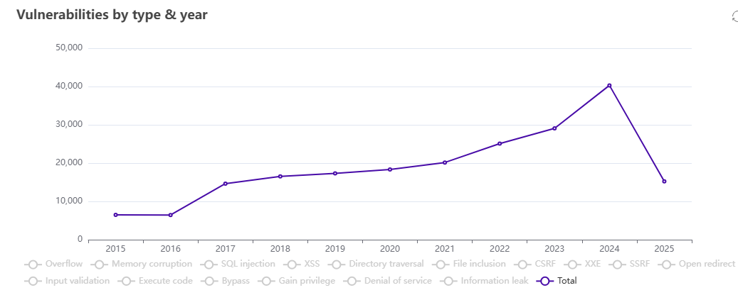

*Figure 1: Source CVEDetails.com (Note: 2025 is year to date (i.e. April) and not annualised)*

Unlike traditional onsite systems, cloud environments operate on distributed infrastructures, often depending on remote access and shared resources. This architecture introduces unique security risks, as cloud applications are accessible from numerous networks and devices, resulting in potential evasion of traditional security measures. Attackers can exploit these vulnerabilities through various techniques such as credential theft, privilege escalation, and lateral movement, posing serious risks to cloud security.

## 3.2 Limitations of Traditional Security Models

Traditional security models often assume that everything within an organisation’s network can be trusted, with measures in place to keep external threats out. Unfortunately, this approach in cloud environments is insufficient. Cloud applications frequently interact with external networks making them prone to insider threats, compromised accounts and attacks that bypass perimeter defences (e.g. Firewalls). Without continuous verification, traditional security models leave opportunities that attackers can exploit, especially in cloud environments with complex and changing access requirements.

## 3.3 Relevance of Zero Trust in AWS

The Zero Trust model solves these critical security vulnerabilities by assuming that no user or device should be trusted by default, regardless of their network location. Operating on the principle of “never trust, always verify,” Zero Trust enforces continuous identity verification and strict access control at every access point. This model aligns with modern security standards by ensuring that every access request is authenticated and authorised. AWS “Amazon Web Services”, the leading cloud services provider, supports the implementation of Zero Trust through features such as IAM and MFA. These tools enable fine-grained access control and layered identity verification, significantly reducing the risk of unauthorised access.

## 3.4 Serverless Approach in Cloud Environments

The serverless model in computing allows for applications and services to be built and run without the need for operating servers locally. This therefore removes the risk of having to provision, manage and scale the infrastructure required. Another relevant model is SaaS “Software as a Service” representing a pay-as-you-go service, with no upfront costs. High availability is provided by the cloud service providers, allowing for reliability and redundancy if an incident event occurred. These advantages align well with the project’s approach for the development of a secure application, requiring reliability while reducing the amount of management needed, lowering the chances of possible disruption.

## 3.5 Common Web Application Risks: An Overview of the Open Web Application Security Project “OWASP” Top Ten

This section covers the OWASP Top Ten vulnerabilities. It discusses the risks, impact on cloud-based web applications, highlighting the critical importance of adopting the Zero Trust model. Cloud web applications are often the primary targets for malicious actors due to their exposure over the internet, role in handling confidential data and user interaction. The OWASP has gathered a widely known list of the most critical security risks facing web applications.

### 3.5.1 Broken Access Control

This occurs when applications fail to enforce permissions properly, allowing unauthorised users to access, modify, or delete data. According to Common Weakness Enumerations “CWEs”, broken access controls is one of the most frequently encountered vulnerabilities with studies showing that up to 94% of applications tested, exhibited some form of this issue. It can lead to consequences such as data leakages, escalation of privileges and the complete compromise of systems. Prevention generally involves using strict server-side access controls, and trusted application programming interfaces “APIs” that stops the manipulation of control metadata by attackers.

### 3.5.2 Cryptographic Failures

Cryptographic failures, originally known as sensitive data exposure, involves weaknesses where data is encrypted or transmitted. Failures often cause the exposure of sensitive information to unauthorised parties due to outdated protocols, weak algorithms, or misconfigurations for encryption. To limit such risks all confidential information should be encrypted using industry standards (e.g. Transport Layer Security “TLS” v1.3), avoid weak cryptographic implementations, and encryption is applied both at rest and in transit.

### 3.5.3 Injection

Structured Query Language “SQL” or Not Only SQL “NoSQL” injections occur when untrusted data is sent to a command handler as part of any query or operation. Attackers can exploit these flaws to gain access or manipulate backend systems or databases. This category remains one of the most common and perilous, particularly when user inputs in forms or fields are not validated correctly. To avoid this, applications should have parametrised queries and ensure that user inputs are validated and sanitised.

### 3.5.4 Insecure Design

Insecure design occurs due to built-in weaknesses within an application from the lack of secure development practices. This also includes failing to consider threat modelling, weak architectures and or insecure design patterns. Preventing insecure designs requires the constant use of secure coding principles and continuous evaluation of potential threats. Additionally, the Secure Development Lifecycle “SDLC” should be used for applications, which involves conducting regular code reviews and frequent security tests to protect against known attack vectors.

### 3.5.5 Security Misconfiguration

This is a broad issue encompassing poorly configured permissions, unnecessary features are enabled or installed, or the use of default accounts (e.g. root user). It is a common reason for system compromise and often happens by failing to implement hardening measures or skipping routine maintenance. To mitigate these risks environments should be set up in structured manner, following a repeatable hardening process, including an automated method to be able to verify the effectiveness of configurations and secure installation practices that align with least privilege and defence in-depth principles.

### 3.5.6 Vulnerable and Outdated Components

The usage of outdated or unsupported components like libraries, frameworks, or operating systems can expose applications to known vulnerabilities. This is especially dangerous when developers are unsure about the versions used in both client-side and server-side code. To be able to mitigate this a patch management strategy should be implemented, alongside using automated tools to track component versions. Furthermore, when third party dependencies are used, they should be from an authentic repository and regularly scanned for vulnerabilities.

### 3.5.7 Identification and Authentication Failures

Failures relating to identification and authentication mechanisms arise when MFA is missing, passwords are weak, or tokens for sessions for example are handled poorly. These issues can cause automated attacks like credential stuffing where an attacker has a list of user credentials, brute force attacks or session hijacking. The solution involves applying strong password policies and mandating MFA. Furthermore, the usage of secure session management and rate limiting authentication attempts are also crucial to protect against the listed attacks above.

### 3.5.8 Software and Data Integrity Failures

This occurs when systems cannot ensure that data or code has not been tampered with. This is relevant in environments where components such as CI/CD “Continuous Integration / Continuous Deployment” (e.g. GitHub Automated Updates) or plugin systems can introduce malicious code. Therefore, trusted sources for dependencies (e.g. npm) should be used to verify code integrity digital signatures or checksums should be applied. Additionally, Automated software and manual code reviews help to ensure that deployed code is verified and authorised.

### 3.5.9 Security Logging and Monitoring Failures

Lack of logging and monitoring allows for malicious actors to operate undetected, delaying incident response or even preventing detection completely. To counter this, all critical components logging should be enabled and stored securely. Ensuring that logged data is structured and encoded correctly to avoid injection attacks and is regularly reviewed. The integration of alerting tools also enhances visibility and permits for proactive threat detection.

### 3.5.10 Server-Side Request Forgery (SSRF)

These vulnerabilities occur when an attacker tricks a server into making requests to unintended destinations, potentially evading firewalls or accessing internal resources. This is particularly dangerous in cloud environments. To prevent SSRF, HTTP redirection should be blocked at the application level, mandate “deny by default” network access policies, and ensure validation for every outbound request. Furthermore, strict firewalls rules should be applied to prevent the likelihood of exploitation.

## 3.6 MFA Methods Comparison: TOTP, Email, SMS

MFA is a crucial component in the Zero Trust Model, requiring users to pass two or more layers of verification to gain access to resources. MFA includes 2FA “Two Factor Authentication” approaches where two distinct forms of credentials must be verified. The extra step in security reduces the risk of compromised accounts resulting from the theft of credentials (e.g. usernames, passwords). As shown in Figure 2, common types of MFA include OTPs sent via SMS or email, or app based Time-based One Time Passwords “TOTP” codes and hardware TOTP tokens.

|  |  |  |  |  |
| --- | --- | --- | --- | --- |
| MFA Method | Description | Security Strength | Pros | Cons |
| SMS-Based OTP | A one-time password is sent via SMS to a user’s registered phone number. | Low to Medium | Easy to use; no extra apps required. | Vulnerable to SIM swapping, and mobile delivery can fail or be delayed. |
| Email-Based OTP | A one-time password is sent to the user’s email address. | Low to Medium | Easy to integrate and widely supported (e.g. Gmail, Outlook). | Can be intercepted if the email is compromised; slower delivery. |
| TOTP (Authenticator Apps) | A time-based code is generated in an app (e.g. Google authenticator) | High | No internet needed; resistant to SIM swapping and message interception. | Requires user setup in an app; difficult for non-technical users. |
| Hardware TOTP Token | A physical device generates time-based codes for login (e.g. YubiKey) | Very High | Does not rely on external software; resistant to remote attacks. | Physical setup required; device can be lost, damaged, or forgotten. |

*Figure 2: Comparison of MFA methods based on security strength, usability, pros and cons.*

Among the MFA methods shown in Figure 2, TOTP app-based authentication stands out as the preferable option, offering a strong balance between security and usability in a Zero Trust environment.

TOTP’s security benefits derive from several factors:

1. **Secret key**: The security foundation relies on a shared secret that never transmits during authentication.
2. **Limited validity**: Each code is valid for only 30 seconds, limiting the window for attacks.
3. **One-way function**: HMAC-SHA256 ensures that even if an attacker captures a TOTP code, they cannot reverse-engineer the secret key.

App-based TOTP generates the one-time interval codes using applications such as Google Authenticator, completely offline on the user’s device. This independence from internet connectivity means that it is not affected by delays, or third-party disruptions; issues commonly associated with SMS-Based or Email-Based OTPs. As the strengths and weaknesses listed in Figure 2, show; app-based TOTP is undoubtedly stronger than SMS OTPs which are vulnerable to SIM swapping attacks and email-based OTPs which can be intercepted if a user’s email account is compromised.

Despite the strengths offered by app-based TOTP, it remains vulnerable to phishing attacks, seed theft, and a lack of contextual awareness. This is evident from recent high-profile attacks, including Adversary in The Middle “AiTM” phishing campaigns targeting Microsoft 365 accounts in 2023, where malicious actors intercepted both TOTP codes and session tokens to bypass authentication.

While authentication methods continue to evolve TOTP-based methods currently remain the trusted standard. They are among the most reliable and highly utilised (e.g. app-based, physical device) methods aligning closely with the Zero Trust approach.

# Section 4: Project Development Methodology

This section outlines the tools, processes and strategies used to develop a secure, cloud-based web application aligned with Zero Trust Principles. It builds on the topics raised in the Background Review (Section 3) aligning with the Aims and Objectives set out in Section 2.

## 4.1 Technology Choices and Justification

Throughout this project, the term “application” refers to the complete system, comprising the React-based frontend interface deployed via AWS Amplify. The backend refers to AWS services used for authentication, monitoring, and access control, including Cognito, CloudWatch, and IAM. This explanation helps to distinguish it from the client-side application and cloud infrastructure.

### 4.1.1 AWS Services and Free Tier

AWS was chosen as the cloud infrastructure provider due to its extensive range of services and security features. Crucially, it offers a free learning program called AWS educate, which provides guides, video tutorials and documentation on how to use AWS services. A generous free tier is also provided, permitting cost effective access to cloud resources. This makes it feasible to build, host, and manage a secure web application within the project’s budget constraints.

### 4.1.2 AWS Identity and Access Management

AWS IAM provides fine-grained access control for AWS services, by managing permissions through policies for users (identities with long term credentials) groups (shared permissions for a collection of users), and roles (identities with specific permissions and temporary credentials). Least privilege access is enforced through policies, authentication mechanisms, including usernames, passwords and MFA via TOTP-based authenticator apps and supported hardware security keys.

### 4.1.3 AWS Amplify and Cognito

AWS Amplify and Cognito work together to provide authentication and hosting for the frontend application. Amplify is used to automatically build the React application and deploy it from a connected GitHub repository, which is then hosted publicly via HTTPS “Hypertext Transfer Protocol Secure” and provided with a domain name. It also enables for changes or modifications to be easily made through continuous deployment. Cognito handles user management and authentication via user pools, while supporting different methods of MFA (Email-based OTP, SMS-based OTP and TOTP-based authenticator apps), with a Custom UI (User Interface). By using these services, the system benefits from the AWS ecosystem of services, eliminating the need for complex infrastructure and hosting management.

### 4.1.4 AWS CloudTrail and CloudWatch

AWS CloudTrail and CloudWatch would be used for security auditing and performance monitoring for AWS services and the frontend application. CloudTrail logs all API activity, tracking user actions and resource changes for security and compliance. CloudWatch monitors performance in real-time, collecting metrics, events to detect anomalies and trigger alerts. Together these services ensure visibility and transparency, aligning with the Zero Trust model while reducing the need for manual monitoring and intervention.

### 4.1.5 Development Stack

The development stack consists of a React frontend built using HTML “HyperText Markup Language”, CSS “Cascading Style Sheets” and JS “JavaScript”. HTML serves as a building block for web pages, defining their structure and content by using tags to organise elements such as text, images and forms, which browsers then render for display. CSS is then used to control the presentation and layout of HTML elements, for aspects like fonts, colours and spacing, for consistent and responsive designs across various devices. JS adds dynamic functionality, enabling client behaviour such as allowing for real-time updates, form validation, and communication with backend services.

Following this, the Node.js framework during development is used for building processes, handling package management with npm. Enabling for the inclusion of libraries such as React.js, allows for the integration of modular components, such as the UI interface. Dependencies also include AWS-SDK and amazon-cognito-identity-js for the integration of AWS Services such as Cognito authentication and resource management, furthermore react-router-dom for the management of routing and navigation for single-page applications “SPAs”.

In production, the frontend application would be deployed using AWS Amplify.

## 4.2 System Architecture Design

The system architecture diagram in Figure 3 follows a serverless approach, using AWS managed services for hosting, authentication, security and monitoring. The development process was structured to align with Zero Trust Principles, ensuring that no implicit trust is granted within the system, and that access is strictly controlled.

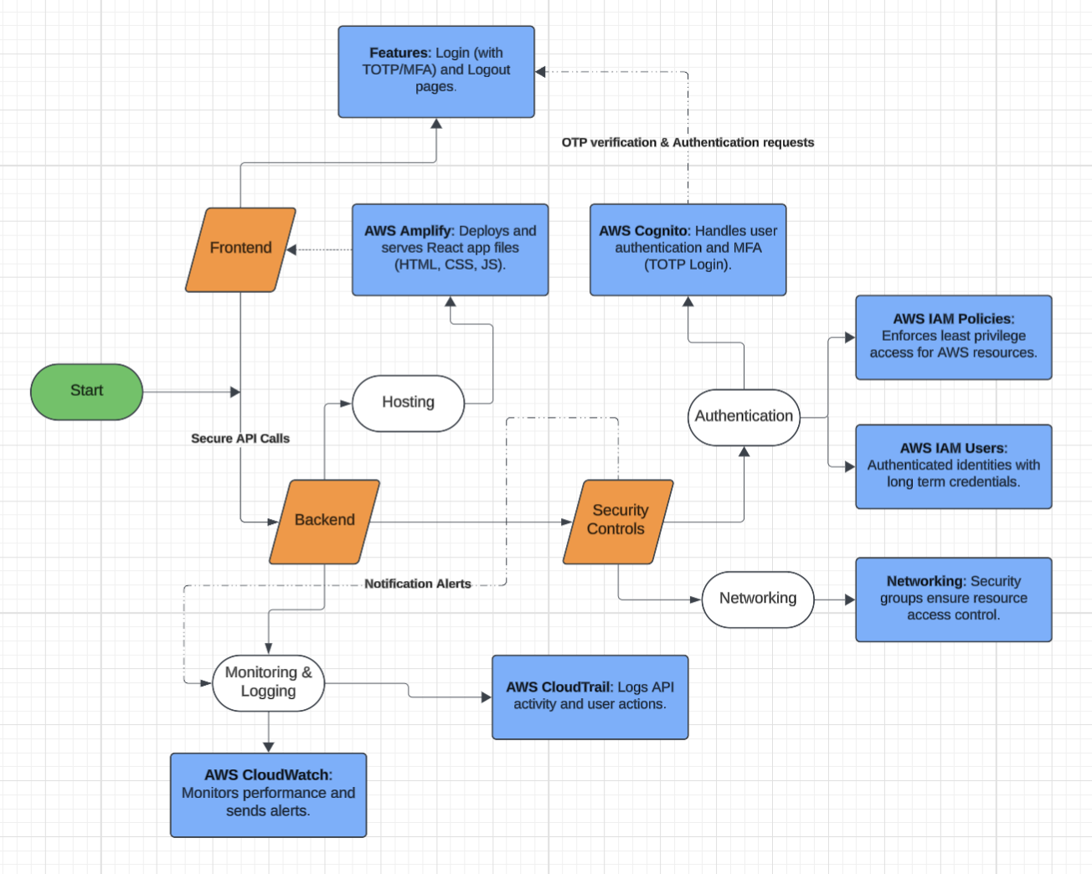

*Figure 3: System Architecture Diagram showing key frontend and backend components.*

## 4.3 Wireframe Designs

In Figure 4, the login menu allows users to enter their username and password. Once the Sign In button is clicked the credentials are validated by AWS Cogito. If the credentials are correct users are redirected to the TOTP screen. For the second stage of the MFA process, users are prompted to enter a TOTP generated by an authenticator app (e.g. Google Authenticator or Authy), requiring an additional layer of verification beyond the password. However, if a user becomes stuck on the MFA page or an unexpected error occurs, they’re able to return to the login menu.

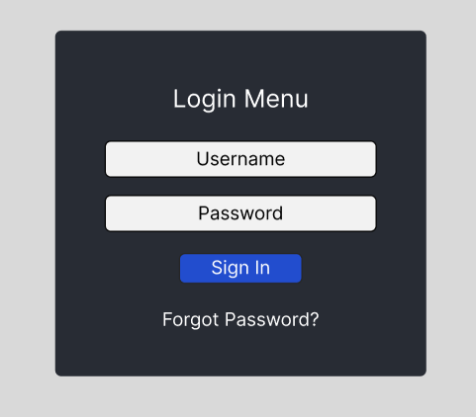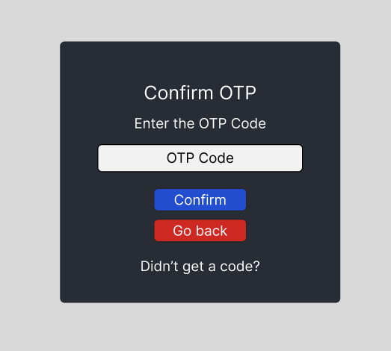

*Figure 4: Wireframe mock-ups of the login and TOTP (Time-Based One Time Password) authentication pages.*

## 4.4 Testing Strategy

The testing strategy was based on two methods: white box (full knowledge) and black box (no knowledge) testing of the entire system. This included both the React frontend and the AWS backend services. The strategy was designed to ensure compliance with Zero Trust Principles of “never trust, always verify” by assuming there is always a weakness or entry point.

## 4.4.1 Testing Tools: OWASP ZAP, Nmap and cURL

These tools were used to perform black box vulnerability assessments, with each targeting different areas of the frontend system architecture.

* Nmap, a network scanning tool was used to determine which network ports were open on the deployed frontend application. This helped to verify that only required services (e.g. HTTPS on Port 443) were accessible from the internet.
* cURL “Client for URLs” was utilised to retrieve HTTP and HTTPS response headers from the Amplify-hosted frontend. This aided find to relevant security headers which were either absent or present (e.g. CSP, HSTS).
* OWASP ZAP “Zed Attack Proxy”, a security testing proxy, was utilised with both active and scanning techniques. It was configured to crawl the frontend application and test different components against common-web vulnerabilities (See Section 3.5 - OWASP Top Ten). The tool generated a detailed report revealing identified issues, their severity levels, and recommended remediations.

## 4.5 Evaluation Strategy

The evaluation focused on comparing the system’s security posture before and after the implementation of IAM and MFA measures.

Key metrics included:

* Failed login attempts tracked by Cognito Events CloudWatch logs.
* Vulnerability counts from tools such as OWASP ZAP grouped by severity levels (e.g. high, medium, low, informational).

# Section 5: Implementation

This section provides a breakdown of the various stages during system development, highlighting key decisions, technical challenges and security considerations. It follows the Methodology discussed in Section 4 above and aligns with the Zero Trust model.

## 5.1 Research and Experimentation

During the early development phase AWS Educate was used as a key learning platform, offering an extensive library of free training courses. This permitted learning about AWS’s broad set of products to include compute, storage, and databases. A new user account was created, using the free tier benefits provided, a range of tools were used for practical testing. This included EC2 “Amazon Elastic Compute Cloud” allowing for virtual servers to be hosted, S3 “Simple Storage Service” objects and data to be stored inside buckets. VPC “Virtual Private Cloud” attached to an EC2 instance for network isolation, RDS “Relational Database Service” for managing relational databases. CloudWatch was then used for the collection of metrics to issue alarms for potential anomalies, IAM was also explored creating users and groups with assigned policies to gain a better understanding about permission boundaries and access control (See Appendix 2 for AWS Educate activities).

Following this, the technology stack initially chosen for development consisted of an application to run on an EC2 instance, using the Node.js framework. Including React.js for the frontend and express.js for API calls to fetch server-side data from Amazon RDS with MySQL.

However, as discussed in Appendix 3 the approach introduced many challenges and managing infrastructure manually proved to be too time consuming and extremely complex. Unfortunately, this EC2 hosted model was unable to take advantage of the free tier benefits provided by AWS.

Therefore, the technology stack was restructured to solve these issues by focusing on a serverless approach, mainly relying on AWS managed services. This included AWS Amplify for automated builds, deployments and frontend hosting for the React.js application in production mode. AWS Cognito replaced the manual authentication system, enabling secure user sign-in and MFA support. For the security aspects such as IAM, CloudTrail and CloudWatch these remained unchanged. These are key components used for access control, logging and monitoring the backend system. A new development roadmap was also created based on the objectives set out in Section 2.2, to align more closely with Zero Trust principles.

## 5.2 Building the Foundation

Wireframes were then designed for the login and TOTP verification screens to illustrate the authentication workflow (See Figure 4 for the mock-up designs). Additionally, a system architecture design was produced to demonstrate the layout and blueprint of the application infrastructure, showing both frontend and backend components (See Figure 3). To begin development, the application was initially built on a local machine using the Node.js runtime environment. The Node Package Manager “npm” was used to install JS libraries, including React.js, AWS-SDK and amazon-cognito-identity-js. Once the required packages were installed, the npm start command was executed to launch the development server. The application was made accessible via localhost in the browser for testing and development purposes. A GitHub repository was also created to maintain version control and enable tracking of developmental changes (See Appendix 4 for commands used and specific details).

After this, construction of the frontend login interface based on designs highlighted in the wireframes from Figure 4 began. This involved a minimalist approach, including only essential UI elements such as text fields, buttons and form layouts, optimising the use of space. The chosen key choice of colours consisted of Dark Slate for the background (60%), White for the form fields and headings (30%) and Blue for buttons or other elements. Code reusability was also prioritised during development by creating global style components, enabling consistent styling across multiple screens. (See Appendix 5 for frontend development visuals).

Once the login page design was completed, the next step involved configuring sign-in functionality with AWS Cognito. To support this, IAM groups and users were setup as shown in Figure 5, following least privilege principles. These users were permitted to only access backend services related to their group permissions.

|  |  |  |
| --- | --- | --- |
| Group | User | Password |
| Admins | ZeroTrustAdmin | ZeroTrustAdminDissertation123! |
| Developers | ZeroTrustDeveloper | ZeroTrustDeveloperDissertation123! |
| Regular Users | ZeroTrustRegUser | ZeroTrustRegUser123! |

*Figure 5: IAM Group to User Mappings for AWS Console Access, more details in Appendix 6.*

To prevent unexpected costs from AWS services during development, a limited spending budget was also configured with a limit of £10. This included setting up automated cost monitoring and alerts to notify when expenditure approached the defined threshold, to ensure that the project stayed within budget. Following this, a new user pool in AWS Cognito was created to manage authentication for the frontend application. A test user was also added to verify login functionality, as shown in Figure 6.

|  |  |  |
| --- | --- | --- |
| User Pool Name | Email | Password |
| Zero Trust User Pool | zerotrustdissertation@gmail.com | ZeroTrustUser!123 |

*Figure 6: AWS Cognito User Pool and Test Account, more details in Appendix 7.*

To connect the authentication system to the frontend application, secret configuration keys were used. This included the AWS Region, Cognito User Pool ID, Cognito Client ID and the authentication flow. These credentials were essential for enabling secure communication between the frontend and backend using the aws-sdk and amazon-cognito-identity-js modules.

To implement basic login functionality, a file named authentication.js was created. Custom functions (See Appendix 8), such as SignIn were developed to handle user logins, along with ConfirmPassword, which was used to complete the account setup process after a new user was created.

With everything integrated, the first major test was conducted, as documented in White Box Test 2.

Unfortunately following this test, login functionality didn’t work as planned. This was due to configuration issues, including an incorrect AWS Region and MFA accidentally left as mandatory. Therefore, users were unable to sign in. After resolving these errors, another test (White Box Test 3) was carried out, which showed that the sign in process partially worked, as shown in Appendix 8.

After this, development of MFA functionality could begin and involved additional functions such as VerifyMFACode requiring authentication results from the first stage to work. This required parameter values such as the ChallengeName (the method of authentication being requested), Session (tracking token used to continue the login flow) and TOTP code (a valid time-based code from an authenticator app). During this stage, the MFA interface was also developed and integrated into the same file as the login screen (login.js). If the first stage of authentication is successful, the layout then dynamically switches to display the MFA form, allowing users to enter their code and complete the login process.

However, when another test was performed (White Box Test 4), the integration of TOTP-based MFA proved to be more complex than anticipated. It became clear that more backend logic and configuration would be required to support this feature. Therefore, the decision was made to delay development of TOTP and instead implement Email-based OTP, which was significantly easier to configure and develop. The implementation is detailed in Appendix 9.

The next step was to explore session management alongside navigation handling in react, due to potential similarities with react native routing previously studied in the CSY3063 mobile computing module. This involved using modules such as react-router-dom to manage navigation based on the authentication state. During practical experimentation, this was attempted with the goal of redirecting users to the menu page after successfully passing through the 2FA process. However, during White Box Test 6, it was discovered that redirection was not functioning as expected. Despite successful authentication, users were not being navigated away from the login screen. Due to complexity issues, it was decided react routing would be revisited later.

Within session management, it was clear that a local session needed to be created. Authentication results after the 2FA process allowed the retrieval of critical values such as access tokens, ID tokens, refresh tokens, and user session data. The combination of this data enabled the creation of a local session, which was handled by a custom function called SetCustomSession, triggered once a user completed the authentication process. To fetch the session status, the function GetSessionStatus was developed returning values of either true or false. Building on this, conditional logic was implemented for app.js to manage routing (temporary work around to react-router-dom). If the sessions status was true, users would be taken to the menu page, if false they would be directed back to the login screen. A similar condition was implemented for the SignOut function, which cleared the session and made sure that users were properly signed out both locally and in AWS Cognito.

## 5.3 Securing the Application

The security phase, was of vital importance to ensure that the frontend application and AWS services had the correct precautionary measures in place, narrowing the potential attack vectors of exploitation before the deployment of the frontend application in a production environment simulating a real website. Following the most recent assessment carried out in White Box Test 8, errors logged directly to the browser console could potentially leak sensitive backend information. Therefore, developer logs were implemented, ensuring that logged error outputs were only shown during the internal state of development. Furthermore, another related risk was that hardcoded variables for sensitive credentials of AWS Cognito, were potentially exposed in the frontend facing view of the browser. If left unchecked, malicious actors could hijack these secret keys, gaining access to the backend services such as AWS Cognito, with the intent of malicious harm. The repercussions would be severe, resulting in potential exploitation such as remote code execution or data theft. In response, Cognito credentials were separated from the main codebase and stored in a .env file for secrecy (Appendix 10.1).

Lastly, in the AWS console, IAM users were also discovered to be lacking MFA authentication. This was especially the case for users allocated with higher levels of privilege. As such they were susceptible to unauthorised access in the event of credential theft. To mitigate this risk, MFA was mandated for all IAM users, regardless of their group or privilege level, in alignment with Zero Trust principles this assumed no user or account by default could be trusted. Following this, another assessment of the system was conducted (White Box Test 9), during which no vulnerabilities were discovered. As a result, the frontend application was deemed ready for deployment in a production environment. The GitHub repository previously created for the project was connected to AWS Amplify, allowing the frontend application to be automatically built and deployed, as shown in Appendix 10.3.

## 5.4 Monitoring and Threat Protection

The objective here was to track user actions within the frontend application through logging activity and generating alerts for abnormal behaviour.

To achieve this, AWS’s Cognito’s Advanced Security features were enabled in audit-only mode, allowing the capture of authentication related events such as login successes, failures and MFA challenges. These events were automatically passed on to a CloudWatch Log Group (/aws/cognito/userpool/eu-west-2/), enabling for visibility into user actions within the system as shown in Appendix 11.1. However, viewing raw log data directly within the log group was impractical and time consuming. Therefore, a custom CloudWatch dashboard was developed for centralised viewing of all authentication activities for Cognito. It included a bar chart to show the sign-in success rates and failures, along with a detailed log table showing information about login attempts (e.g. geolocation, IP addresses). Furthermore, a CloudWatch Alarm was configured to trigger an email alert if four or more login attempts occurred within five minutes, helping to detect potential brute force or credential stuffing attacks (Appendix 11.3). AWS CloudTrail was briefly explored as a tool for capturing more API actions for Cognito and Amplify. However, due to time constraints and additional complexity, CloudTrail was excluded from the final implementation as shown in Appendix 11.4. Despite this, the monitoring solution implemented worked for proactive threat detection and response aligning with the Zero Trust model. Following this, a vulnerability assessment of the entire system was conducted as detailed in Section 6.2.1.

## 5.5 Security Hardening

Following the vulnerability assessment conducted with tools like OWASP ZAP for automated scanning and manual analysis of AWS services. Improvements were implemented to address weaknesses found across the system and to align with the approach of the Zero Trust model. Tests performed revealed the absence of security HTTP headers, the potential overuse of administrator privileges for IAM users and areas for where authentication could be improved as shown in Appendix 12.

To mitigate these risks custom security headers were enforced in the Amplify hosted frontend, using the customHTTP.yml configuration file. These headers included HSTS “Strict Transport Security”, CSP “Content Security Policy”, X-Frame-Options, X-Content-Type-Options, and Referrer Policy. Each of these headers helps to protect against client-side delivery threats such as downgrade attacks, clickjacking and the leakage of potentially sensitive information (Appendices 12.3.1 & 13.1). In addition, IAM users’ permission policies were refined. It was also discovered that the ZeroTrustDeveloper initially had administrator privileges which violated the principle of least privilege access. Therefore, the permission policy was removed from the user along with unused access keys. By doing this, potential attack vectors into AWS services were closed off.

During the frontend application stage, react routing and navigation was reworked for further expandability and greater access control to prevent unauthorised screen access. This involved revisiting the react-router-dom module, introducing GuestRoutes and ProtectedRoutes components to enforce route protection for screens. If an unauthenticated user attempted to access the dashboard page for example, they would be redirected back to the login page. On the other hand, if an authenticated user visited the login or MFA page they would be redirected back to the dashboard. This logic enabled consistent session-based navigation and reduction in unauthorised access by Uniform Resource Locator “URL” manipulation (Appendix 13.2). Furthermore, TOTP-based authentication was implemented in Appendix 13.3 & 13.4, replacing Email-based MFA. This made sense as emails are more susceptible to attacks such as phishing or even interception by third parties.

Once security hardening was completed another vulnerability assessment was conducted to determine the effectiveness of the implemented measures as detailed in Section 6.2.2.

# Section 6: Testing and Evaluation

## 6.1 White Box Testing

Short-form assessments were conducted on both frontend and backend components.

|  |  |  |  |
| --- | --- | --- | --- |
| Test ID | Test Objective | Result and Issues | Resolution |
| 1 | Login Interface Design (Frontend) | Partial Success – CSS Styling inconsistencies for margin and padding between UI elements. | Introduced globalStyles.js for reusable component styling and consistent layouts. |
| 2 | Login Authentication Functionality (Frontend) | Fail – Incorrect AWS region set for the Cognito key; MFA left as mandatory. | AWS region value updated to eu-west-2; MFA temporarily set to optional for testing purposes. |
| 3 | Login Authentication Functionality (Frontend) | Partial Success – Login was successful, but an undefined error appeared in alerts. | Removed error value from the from success alert component. |
| 4 | MFA Authentication TOTP Functionality (Frontend) | Fail – Continued to receive ‘ChallengeName’ errors; TOTP auth setup was not possible via the AWS portal, more functionality required. | Replaced TOTP authentication with email-based MFA for easier integration (temporary). |
| 5 | MFA Authentication Email Functionality (Frontend) | Success – No issues | N/A |
| 6 | Navigation Functionality (Frontend) | Fail – The UseNavigate() function would not redirect users away from the login screen once signed in. | Navigation functionality removed temporarily due to redirection failure. Planned to revisit react-router-dom in a later development stage. |
| 7 | Session Management (Frontend) | Fail – The local session was not being retrieved after user authentication, preventing session-based actions. | Implemented await in the session retrieval function, to ensure session data was available immediately after login. |
| 8 | Cognito Security and AWS IAM | Fail – Cognito credentials and backend data were exposed in browser logs or frontend code. IAM users did not have MFA enabled. | Enforced MFA for all IAM users. Developer logs were implemented, and Cognito credentials were moved to environment files outside the main codebase. |
| 9 | System Wide | Success – No issues | N/A |
| 10 | CloudWatch Dashboard (Cognito Security Events) | Partial Success – Login events for specific authentication challenges (e.g. Password & MFA) metrics were not being collected correctly. | Mistake found and corrected in the custom query for filtering login events in CloudWatch. |
| 11 | Navigation Functionality Rework (Frontend) | Fail – Major issues for routing between the AuthNavigator and the DashboardNavigator. (Page navigation not working at all). | Added the <Router> component, which was missing, enabling for page navigation to work correctly. |
| 12 | MFA Authentication TOTP Setup Functionality (Frontend) | Fail – Authenticator app timed code for first time verification for TOTP MFA would return an invalid code error even when the correct code was inputted. | A separate function called verifyTOTP was created to solve this problem, to mark the new user’s software token MFA status as verified. |

*Figure 7: White Box Testing Table with logs for shorter forms of assessments.*

## 6.2 Black Box Testing

Two major vulnerability assessments Pre and Post Implementation (detailed below) were carried out at different stages of development to evaluate the system’s overall security stance. These assessments used a combination of automated tools (OWASP ZAP, Nmap, cURL) and targeted manual testing to:

* Identify potential vulnerabilities,
* validate existing security configurations; and
* recommend remediation strategies.

## 6.2.1 Pre-Implementation Vulnerability Assessment

The initial assessment was conducted before security hardening measures were applied, the table below summarises the tests conducted, key findings, and results.

|  |  |  |  |  |
| --- | --- | --- | --- | --- |
| Test | Finding | Risk & OWASP Mapping | Implications | Remediation |
| Nmap Port Scan | Only ports 80 (HTTP) and 443 (HTTPS) were open, no additional ports were detected. | N/A | The presence of these two ports is expected for a web application. Port 80 was open, but traffic is redirected to port 443 which is acceptable. | ✅ Acceptable configuration: No mitigation required. |
| cURL Header Scan | The frontend application’s response headers were missing key security headers, including Content Security Policy (CSP), HTTP Strict Transport Security (HSTS). | 3.5.5 Security Misconfiguration, 3.5.6 Vulnerable Components. | These missing headers leave the frontend application vulnerable to client-side attacks. For example, CSP prevents code injection, and HSTS prevents protocol downgrade (the use of insecure HTTP sessions). | ❌ High Priority: Security headers need to be configured via Amplify’s custom HTTP settings. |
| OWASP ZAP Scan | The scan revealed 3 Medium, 4 Low and 9 Informational risks (Total: 16). Key concerns included missing security headers and the exposure of hidden development files (e.g. hg). No high-risk vulnerabilities were found. | 3.5.5 Security Misconfiguration, 3.5.6 Vulnerable Components. | Despite the absence of high-risk vulnerabilities, the exposure of hidden files could leak sensitive data (e.g. source code, credentials). Combined with missing security headers the likelihood of client-side exploitation increases. | ❌ Medium Priority: Remove unused developer files in production builds. |
| IAM Users, Roles, and Policies | The developer account ZeroTrustDeveloper had AdministratorAccess permissions and retained active access keys. | 3.5.5 Security Misconfiguration | Over-privileged accounts with unused access keys, are among the most exploited vectors in cloud environments. If the access key were to be leaked, the attacker could gain unrestricted access to AWS, leading to compromise of services and data. | ❌ High Priority: Revoke developer account permissions and remove unused access keys. |
| CloudWatch Monitor and Alarms | Login events were being captured, email alerts for failed logins were triggered but no session tracking was implemented. (Frontend Application only) | 3.5.9 Security Logging and Monitoring Failures, 3.5.7 Identification and Authentication Failures. | Without session-based visibility, this creates a blind spot in monitoring, allowing attacks to go undetected. | ⚠️ Low Priority:  Enable session-level tracking in CloudWatch. |
| AWS Cognito | Threat detection was set to audit-only, meaning there was no real-time blocking of threats (e.g. anomalous IPs). | 3.5.7 Identification and Authentication Failures. | Cognito’s audit mode simply logs anomalies without acting, As a result, potential login anomalies could be tracked but not prevented leaving accounts vulnerable. | ❌ Medium Priority:  Enable blocking mode for automated protection against threats  (e.g. botnets) |

*Figure 8: Pre-Implementation Vulnerability Assessment Summary. See Appendix 12 for full details.*

## 6.2.2 Post-Implementation Vulnerability Assessment

The second assessment was conducted after applying all security improvements, the table below summarises the tests conducted, key findings and results.

|  |  |  |  |  |
| --- | --- | --- | --- | --- |
| Test | Finding | Risk & OWASP Mapping | Implications | Remediation |
| Nmap Port Scan | Once again, ports 80 (HTTP) and 443 (HTTPS) were open, no additional ports were detected. | N/A | The presence of these two ports is expected for a web application. No additional exposed ports reduce the potential attack vectors. | ✅ Acceptable configuration: No mitigation required. |
| cURL Header Scan | Security headers including CSP, HSTS, X-Frame-Options and X-Content-Type-Options were present. However, the CSP contained unsafe directives such as ‘unsafe-inline’ and ‘unsafe-eval’. | 3.5.5 Security Misconfiguration, 3.5.6 Vulnerable Components. | Unsafe directives in CSP can be exploited by attackers to inject and run malicious code in the client browser. | ❌ High Priority: Refine the CSP to remove insecure directives (e.g. ‘unsafe-inline’, ‘unsafe-eval’). |
| OWASP ZAP Scan | The scan revealed 5 Medium, 2 Low, and 10 Informational risks (Total: 17). Most were related to weak or missing headers. No high-risk vulnerabilities were found. | 3.5.5 Security Misconfiguration, 3.5.6 Vulnerable Components. | Despite the absence of high-risk vulnerabilities, weak security headers may still allow client-side exploitation and information disclosure. | ❌ High Priority: Further refine the CSP Policy and reduce the number of medium risks reported. |
| IAM Users, Roles, and Policies | MFA is enforced for all key users; least privilege is applied to the developer account ZeroTrustDeveloper.  Old access keys were removed, however CloudTrail logging for user activity was not implemented. | 3.5.9 Security Logging and Monitoring Failures | The lack of CloudTrail logging limits the ability to audit and trace malicious activity, As a result if an AWS account were to be compromised, unauthorised actions in the AWS portal would go unnoticed. | ❌ Medium Priority:  CloudTrail should be enabled to monitor IAM user activity for auditing. |
| Cloudwatch Monitor & Alerts | Login events were being captured, email alerts for failed logins were triggered but session tracking was still not implemented. (Frontend Application only) | 3.5.9 Security Logging and Monitoring Failures, 3.5.7 Identification and Authentication Failures. | No session tracking, introduces blind spots in user activity monitoring, making it difficult to detect session hijacking or misuse. | ⚠️ Low Priority:  Enable session-level tracking in CloudWatch. |
| Web Authentication Security | The /totp-setup authentication page lacks route protection, although error handling is present. | 3.5.1 Broken Access Control | Public access to the TOTP setup route could allow attackers to test or bypass MFA. | ⚠️ Low Priority:  Restrict access to authentication routes using access controls or conditional logic (e.g. authenticated sessions) |

*Figure 9: Post-Implementation Vulnerability Assessment Summary. See Appendix 14 for full details.*

## 6.3 Comparative Analysis (Vulnerability Assessments)

The diagrams below represent the number of vulnerabilities found by OWASP ZAP, categorised by severity level, based on pre and post implementation versions of the frontend application.

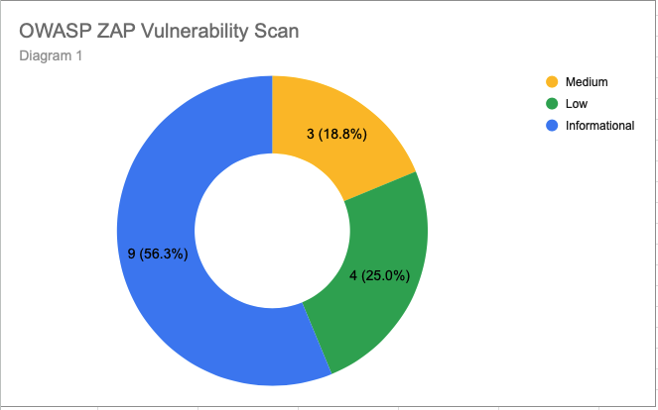

*Figure 10 – OWASP ZAP Vulnerability Scan – Pre implementation.*

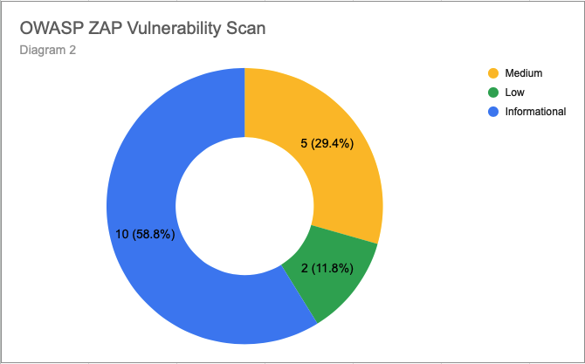

*Figure 11 – OWASP ZAP Vulnerability Scan – Post implementation.*

The two charts above reveal that a greater number of medium-based vulnerabilities were identified in Figure 11 compared to Figure 10, despite the security tightening measures applied in the application post-implementation. This reveals that by remediating an initial issue found (e.g. the lack of security headers: HSTS, CSP) pre-implementation can lead to the introduction of new vulnerabilities as was found in appendix 14.1.1, where the use of insecure CSP headers could be exploited by malicious actors. This reinforces the importance of the Zero Trust approach by “always verify, never trust” and how continuous improvement is required.

# Section 7: Discussion

## 7.1 Disadvantages of the Zero Trust Approach

One of the major disadvantages of the Zero Trust approach with AWS is that advanced security features were locked behind paywalls or subscription models. This included software such as GuardDuty (a threat protection service that continuously monitors AWS environments for malicious activity and provides detailed security findings for visibility and remediation). Due to a limited budget advanced tools such as these could not be used, limiting the project’s scope to mainly using AWS services offering free tier benefits.

As a result, the practical system built has partial security compared to a real life Zero Trust approach, potentially undermining the accuracy and legitimacy of the results obtained.

Introduction of least privilege access for IAM users, groups and policies complicates the configuration of resource permissions, by requiring read and write access-based rules to individual services. This requires both time and human resources vulnerable to mistakes as demonstrated in the pre-implementation assessment above in Section 6.2.1.

It is worth highlighting that in real life, not all companies will have the same financial resources but highlights that capital expenditure on cyber-security is not a cost which can be reduced.

## 7.2 Future Improvements in the Project’s Approach

To improve the project’s approach, if more time and resources were available, several areas would be explored particularly the use of databases. During the research and experimentation phase, AWS RDS databases were practically tested (Appendix 2). The original plan involved integrating MySQL relational databases into the system’s architecture to securely store user data (Research and Experimentation - Section 5.1). This would have been revisited to include the development of a schema diagram for user tables, containing attributes (e.g. first name, dob and addresses).

This information would then be retrieved through server-side API calls to the frontend application, displayed to users (personal information only) once they had successfully signed in. Additional improvements would include the introduction of higher privileged users with the ability to create, read, update and delete data (CRUD operations). As a result, this would make the application a more realistic representation of a production grade web environment.

With more time and budget, a wider and larger test universe would have been used to achieve high confidence levels in the vulnerability assessments. Future improvements could have included progressing beyond manual testing or vulnerability scanning to complete penetration testing. This could have helped to identify and resolve critical vulnerabilities such as SQL Injection (as discussed in Section 3.5.3). Further testing scenarios could be explored such as post-exploitation involving the simulation of an attacker attempting to retain access within the system or application.

In addition, CloudTrail logging would have been implemented for auditability reasons allowing tracking of all users and service activities as discussed in the methodology (Section 4.1.4). This would involve enabling CloudTrail to capture management events for services such as Amplify and CloudWatch, creating a trail to track API activity, and storing these logs encrypted in an S3 bucket. Furthermore, CloudTrail logs would have been sent to CloudWatch Logs, where metric filters and alarms would be configured to trigger alerts for certain API actions, ensuring real-time detection of backend AWS services.

## 7.3 Achievements in the Project’s Approach

The project mainly succeeded in its primary aim: To design and implement a secure experimental cloud-based web application that aligns with Zero Trust Principles by utilising AWS services, IAM and MFA. Throughout the project one of the most notable achievements was the enforcement of TOTP app-based MFA through AWS Cognito (Section 5.5). This was despite the struggle and complexity of its integration during the security hardening phase. Unlike alternative MFA methods such as email and SMS-based OTP’s, TOTP offers a significantly higher level of protection against SIM swapping, and phishing attacks (Section 3.6). The implementation of app-based TOTP not only strengthened authentication flows but also ensured compliance with Zero Trust Principles by enforcing layered identity verification and assuming that no user should be trusted by default.

Furthermore, the projects approach transitioned from a standard EC2-hosted model to a modern serverless architecture using services such as AWS Amplify (Section 5.1). This move reduced the need for manual intervention and configuration, potentially limiting the number of attack vectors. It further supports the Zero Trust model, where each service is isolated and controlled through authorisation by IAM. By configuring services like Amplify and Cognito the system backend on a combined basis was able to enforce fine-grained access control and function under the principle of least privilege.

In addition, security monitoring and proactive threat detection functionality were partially integrated using AWS CloudWatch. AWS Cognito sign-in attempts and events were captured and monitored in real-time (Section 6.2.2). However, session tracking was not fully implemented, and CloudTrail logging for backend IAM user activity was skipped, limiting complete visibility. Alerts were configured to detect anomalous activity such as repeated failed logins or attempts. If such an incident were to occur, the alarm system would be triggered delivering a notification immediately via email to the system administrator, enabling for swift incident response (Section 5.4). This approach partially aligns with the Zero Trust model by enforcing continuous monitoring, although further improvements would be required to achieve complete coverage as discussed in Section 7.2.

## 7.4 Economic Implications in the Project’s Approach

Implementing Zero Trust Principles does require an initial investment in AWS services. This is financially and in terms of resources, both physical and human. Despite this, the project’s approach demonstrates how establishing and embedding effective cyber TOTP practises and budget controls (e.g. cost alarms) can make cloud security accessible even with limited resources.

In the long run, the Zero Trust model provides evidence that albeit not fool proof, businesses through its implementation can prevent data breaches, resulting from malicious attacks permitting access to a firm’s internal systems using compromised credentials. Implementation and enforcement of least privilege access helps limit the attacker’s impact, minimising the threat of service disruption or the theft of sensitive information. This helps to protect firms against financial loss, protecting their reputation, brand integrity and market share.

## 7.5 Legal and Regulatory Compliance

Whilst this project was not required to explore or comply with current legal rules and regulations this is not something which can be ignored. Nonetheless the project’s approach by using AWS aligns with legal issues such as the United Kingdom GDPR “General Data Protection Regulation” for organisations to securely store confidential data. By enforcing strict access controls for AWS resources this aligns with privacy requirements. The partial inclusion of logging and monitoring services demonstrates compliance, accountability and can be audited. For example, in the event of a Zero Day exploit leading to a ransomware attack, by law the incident would have to be reported to the governing authorities, requiring a thorough investigation to identify the scope and impact of the breach. Continuous monitoring activity logs permit traceability, revealing information about affected services or the exposure of confidential data. If required, this evidence can be gathered to justify actions taken for submission to any official governing body. By complying with government requirements, the organisation is demonstrating evidence of best prevailing security practices. Hence reducing the risk of reputational damage, any legal fines, through demonstrating compliance with rules and regulations.

# Section 8: Conclusion

The approach built and achieved with Zero Trust Principles of a secure cloud based with AWS is of major importance to solve issues against modern day cyber threats.

The results highlight that by conducting two major vulnerability assessments of the system, this is insufficient, and that unauthorised access remains a risk (Section 6.2.2). That no single method or approach can prevent vulnerabilities and even new security features can bring new risks or flaws. To prevent potential attacks from occurring in the first place, reinforcing existing systems, preparedness to attacks and continuous verification is always required using least privileged access with layered identity verification.

In the final analysis it is worth emphasising that implementing even basic Zero Trust approaches can be still highly effective, in reducing unauthorised access with IAM and MFA in cloud-based web applications. Businesses which do not leave themselves open to potential attacks, reputational damage and government fines.

# Section 9: References, Information Sources that Provide a Context for the Project.

Roslan, N. I., Mazman, N. T. & Johari, N. F. A. (2024) *Zero Trust architecture: A paradigm shift in network security.* TechRxiv. Available at: https://www.techrxiv.org/doi/full/10.36227/techrxiv.172165641.12548858/v1 (Accessed: 1st October 2024).

Wang, W., Sadjadi, S. M., Rishe, N. & Mahara, A. (2024) *Applying transparent shaping for Zero Trust architecture implementation in AWS: A case study.* arXiv. Available at: https://arxiv.org/pdf/2405.01412 (Accessed: 30th September 2024).

Amazon Web Services (2020) *Zero Trust architectures: An AWS perspective.* AWS Security Blog. Available at: https://aws.amazon.com/blogs/security/zero-trust-architecture-an-aws-perspective/ (Accessed: 11th February 2025).

Amazon Web Services (n.d.) *AWS Well-Architected Framework.* Available at: https://aws.amazon.com/architecture/well-architected/ (Accessed: 8th April 2025).

Amazon Web Services (n.d.) *AWS documentation.* Available at: https://docs.aws.amazon.com/ (Accessed: 15th April 2025).

Mozilla Developer Network (2024) *HTML: HyperText Markup Language.* Available at: https://developer.mozilla.org/en-US/docs/Web/HTML (Accessed: 7th April 2025).

Mozilla Developer Network (2024) *CSS: Cascading Style Sheets.* Available at: https://developer.mozilla.org/en-US/docs/Web/CSS (Accessed: 7th April 2025).

Mozilla Developer Network (2024) *JavaScript (JS).* Available at: https://developer.mozilla.org/en-US/docs/Web/JavaScript (Accessed: 7th April 2025).

Meta Platforms, Inc. (2024) *React – A JavaScript library for building user interfaces.* Available at: https://react.dev/ (Accessed: 7th April 2025).

OpenJS Foundation (2024) *Node.js.* Available at: https://nodejs.org/en (Accessed: 7th April 2025).

Chowhan, K. (n.d.) *Hands-on serverless computing: Build, run and orchestrate serverless applications using AWS Lambda, Microsoft Azure Functions, and Google Cloud Functions.* Packt Publishing. Available at: https://nelson.northampton.ac.uk/discovery/fulldisplay?docid=alma991001532991707361&context=L&vid=44NORTH_INST:44NORTH_INST&lang=en&search_scope=MyInst_and_CI&adaptor=Local%20Search%20Engine&tab=Everything&query=any,contains,Serverless%20Approach%20in%20Cloud%20Environments&offset=0 (Accessed: 8th April 2025).

Amazon Web Services (2024) *AWS Amplify documentation.* Available at: https://docs.amplify.aws/ (Accessed: 15th April 2025).

OWASP Foundation (2023) *OWASP top ten web application security risks.* Available at: https://owasp.org/www-project-top-ten/ (Accessed: 15th April 2025).

OpenAI (2025) *ChatGPT (April 2025 version).* Available at: https://chatgpt.com (Accessed: 23rd April 2025) - ChatGPT was used to assist with research, idea structuring throughout the dissertation and for refinement specifically in Sections 3.1, 3.2 & Appendix 3. All final content and analysis being my original work.

Amazon Web Services (n.d.) *Logging Amazon Cognito API calls with AWS CloudTrail.* Available at: https://docs.aws.amazon.com/cognito/latest/developerguide/logging-using-cloudtrail.html (Accessed: 1st Feb 2025).

Acunetix (2025) *Strengthen your web applications with HTTP security headers.* Available at: https://www.acunetix.com/blog/articles/http-security-headers-web-applications/ (Accessed: 13th April 2025).

Nmap Project (2025) *Nmap: The network mapper.* Available at: https://nmap.org/ (Accessed: 17th April 2025).

OWASP Foundation (2025) *OWASP ZAP: Zed Attack Proxy documentation.* Available at: https://www.zaproxy.org/docs/ (Accessed: 12th April 2025).

Jimmy, F. (2022) *Zero Trust security: Reimagining cyber defense for modern organizations.* International Journal of Scientific Research and Management (IJSRM), 10(4), EC-2022-887–905. Available at: https://doi.org/10.18535/ijsrm/v10i4.ec11 (Accessed: 16th April 2025).

Subudhi, S. (2024) *Comparative Analysis of Multi-Factor Authentication Mechanisms in Enhancing Cloud Security.* International Research Journal of Modernization in Engineering Technology and Science, 6(7), 179–188. Available at: https://doi.org/10.56726/IRJMETS59848 (Accessed: 20th April 2025).

CVEDetails.com (2025) *Vulnerabilities by Type and Year.* Available at: https://www.cvedetails.com (Accessed: 18th April 2025).

Toulas, B. (2022) 'Hackers use AiTM attack to monitor Microsoft 365 accounts for BEC scams', *BleepingComputer*. Available at: https://www.bleepingcomputer.com/news/security/hackers-use-aitm-attack-to-monitor-microsoft-365-accounts-for-bec-scams/ (Accessed: 26th April 2025).

Microsoft (2023) *DEV-1101* 2025). *enables high-volume AiTM campaigns with open-source phishing kit*. Microsoft Security Blog. Available at: https://www.microsoft.com/en-us/security/blog/2023/03/13/dev-1101-enables-high-volume-aitm-campaigns-with-open-source-phishing-kit/ (Accessed: 26th April)

# Appendix 1: Project Timeline

The project timeline was structured to complete the key objectives detailed below, divided across different stages of the development lifecycle.

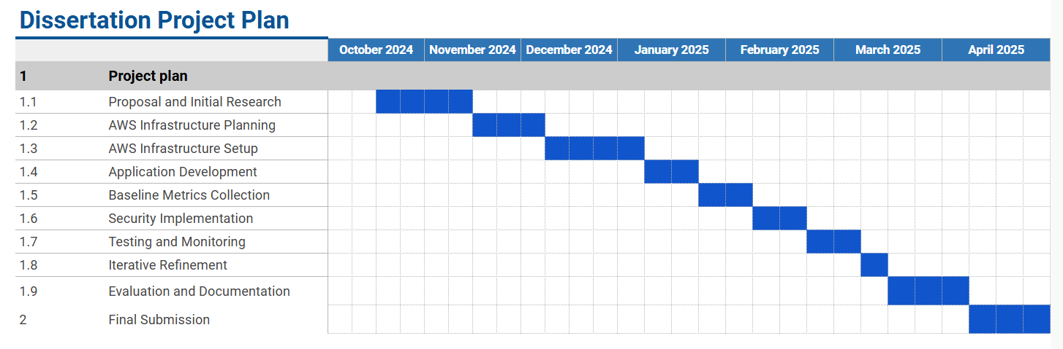

# Appendix 2: AWS Educate Activities

Step 1: Learnt about the AWS Management Console, Billing Considerations and Practice.

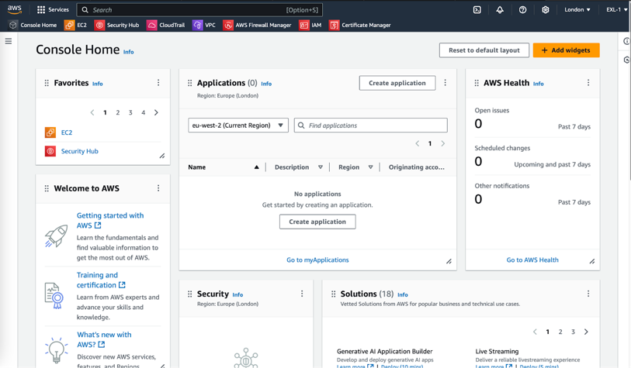

Step 2: S3 Bucket created called testingbucket-2958595849, uploaded tutorial code files and displayed them as public for accessibility.

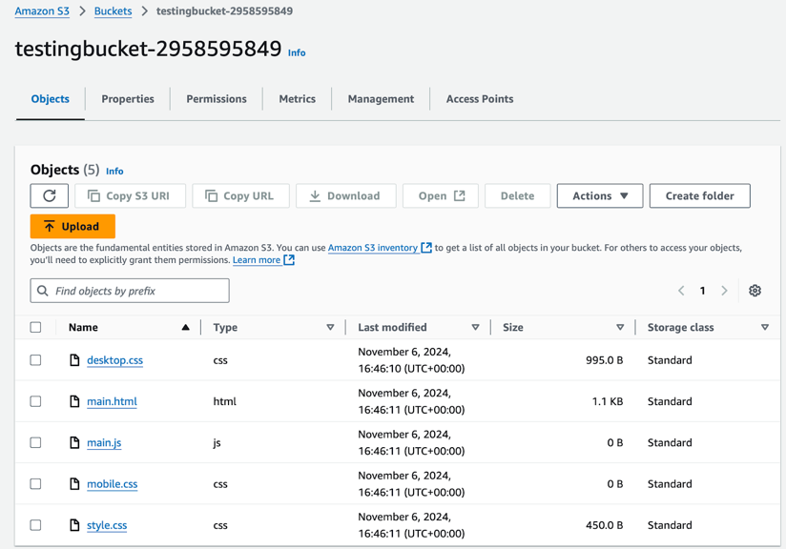

Step 3: Created an EC2 Instance, named Testing-Amazon-EC2. Configuration of security, Computation specifications, VPC and additional settings for a basic web server.

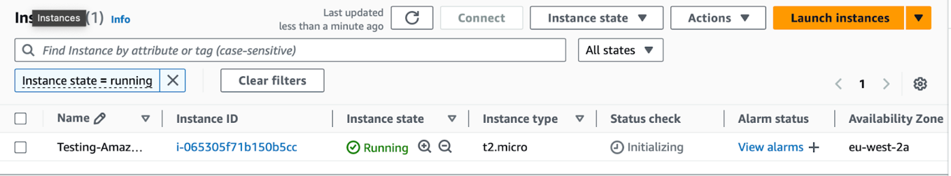

Step 4: VPC named DEMO-vpc assigned to the EC2 Instance.

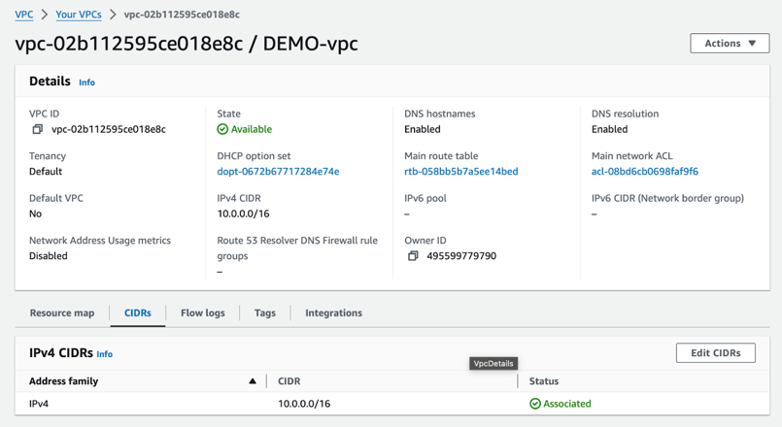

Step 5: Used Amazon RDS to create a MySQL database (default credentials).

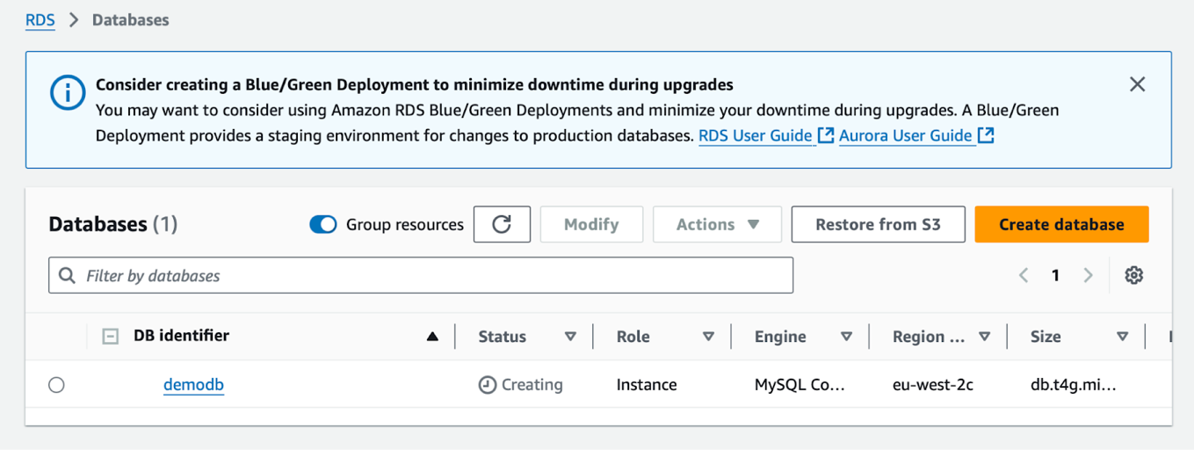

Step 6: Learnt about IAM, created users and groups, and reviewed security recommendations such as enforcing MFA.

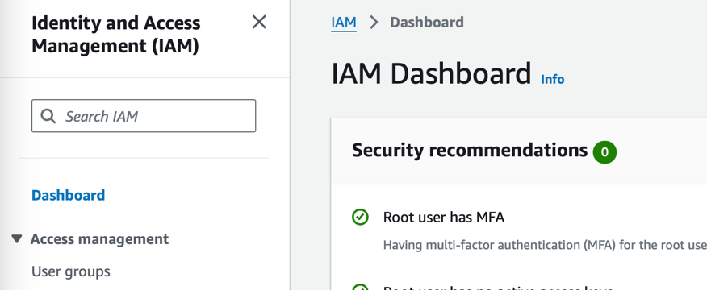

Step 7: Learnt how to configure CloudWatch Alarms, an alert was set up to monitor CPU utilisation of the EC2 instance, triggering when usage exceeded 80% over three data points within 15 minutes.

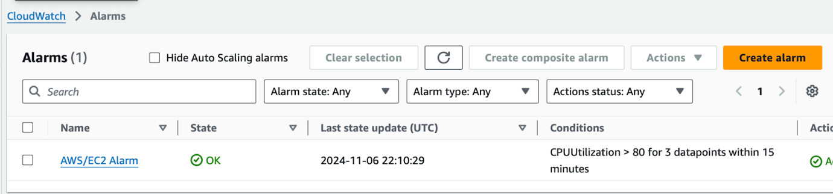

Step 8: Completed the AWS Educate examination and grasped the basics.

# Appendix 3: Initial AWS Experimental Setup

The initial experimental setup began with the creation of a Virtual Private Cloud “VPC” named Dissertation-VPC, configured with an IPv4 CIDR block of 10.0.0.0/16. This VPC serves as the foundational network for the project, offering a secure and scalable environment for hosting cloud resources.

## 3.1 Public Subnet Configuration

A public subnet named Public-Subnet was added to the VPC, configured with an IPv4 CIDR block of 10.0.0.0/24, providing up to 256 IP addresses for hosting internet-facing resources. This subnet was deployed in the eu-west-2a Availability Zone and explicitly associated with the Dissertation-VPC.

Definition: A public subnet is a segment of a VPC that allows resources to have direct internet access through an Internet Gateway “IGW” and public IP addresses.

## 3.2 Internet Gateway

An Internet Gateway “IGW” named Dissertation-IGW was created and attached to the Dissertation-VPC. The IGW acts as a virtual router, enabling the VPC to connect to the internet and supporting communication between resources in the public subnet and external networks.

## 3.3 Route Table Configuration

A route table was configured and associated with the Dissertation-VPC. The table includes the following routes:

* Local Route (10.0.0.0/16): Facilitates internal communication within the VPC.
* Public Route (0.0.0.0/0): Directs internet-bound traffic to the Dissertation-IGW.

The public subnet was explicitly associated with the route table to enforce these routing rules, enabling internet access and internal communication within the VPC.

Tutorial: https://www.youtube.com/watch?v=7_NNlnH7sAg

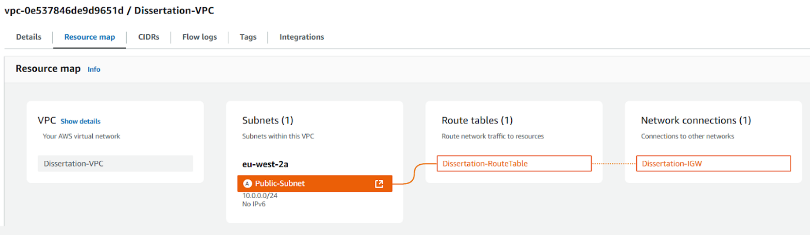

## 3.4 EC2 Instance Setup

An EC2 instance named Dissertation-Secure-Web-Server was created within the Dissertation-VPC, using the Public-Subnet for internet-facing access. The instance was configured with the following specifications:

* Instance Type: t2.micro for cost efficiency and eligibility under the AWS Free Tier.
* Operating System: Amazon Linux for the latest features, performance, and security.
* Security Group: A new Security Group named Dissertation-SG was created with the following inbound rules:
* SSH (port 22): Restricted to a specific IP address for secure administrative access.
* HTTP (port 80) and HTTPS (port 443): Open to the internet (0.0.0.0/0) to allow public access to the web server.
* Storage: 10 GiB of EBS storage, encrypted for data security.
* Key Pair: A new key pair named Dissertation-Key was used to enable secure SSH access.

Tutorial: https://www.youtube.com/watch?v=eaicwmnSdCs

## 3.5 SSH (Secure Shell Protocol)

Using macOS Terminal, the chmod 400 command secured the Dissertation-Key.pem file, and the ssh command was used with the key and public IP to connect to the EC2 instance. After verifying the instance's authenticity, access was granted, confirming a successful connection to the Amazon Linux 2 instance.

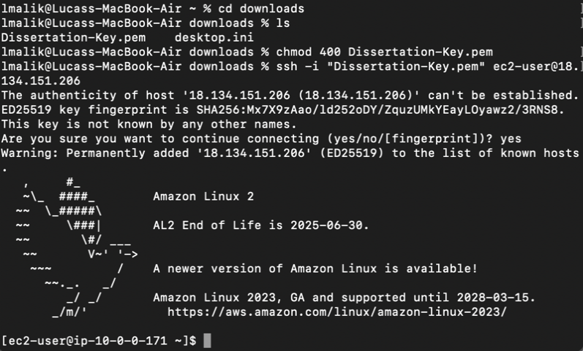

## 3.6 Web Server Setup

To test the EC2 instance, a web server was installed and configured:

Nginx Installation:  
  
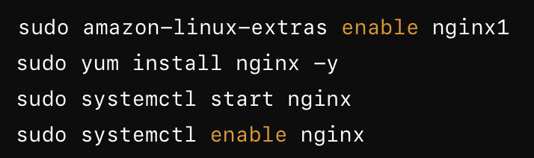

The Nginx web server was installed and enabled to start on boot.

HTML File Deployment:

A basic index.html file was created in the Nginx root directory:  
  
<!DOCTYPE html>

<html>

<head>

  <title>My Test Page</title>

</head>

<body>

  <h1>Welcome to My Dissertation Web Server!</h1>

  <p>This is a test page served from AWS EC2.</p>

</body>

</html>

The file was saved to /usr/share/nginx/html/index.html.

Verification:

The public IP of the instance was accessed via a browser (e.g., http://18.134.151.206), successfully displaying the test page: "Welcome to My Dissertation Web Server!"

This confirmed that the web server was correctly configured and accessible from the internet.

<!DOCTYPE html> <html> <head> <title>My Test Page</title> </head> <body> <h1>Welcome to My Dissertation Web Server!</h1> <p>This is a test page served from AWS EC2.</p> </body> </html>

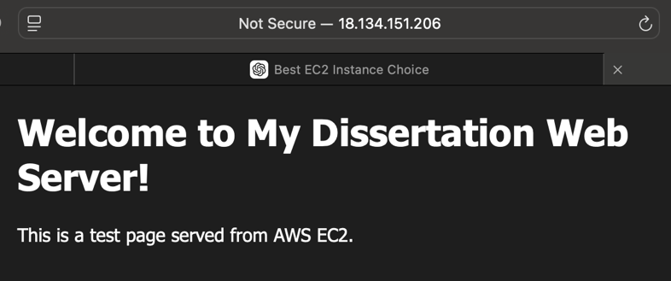

Problems:

The approach was discontinued, due to increasing costs and complexity managing an EC2 instance. Hosting the application would require larger instances (e.g. t2.micro or higher), which falls outside the free tier, resulting in accumulating hourly charges.

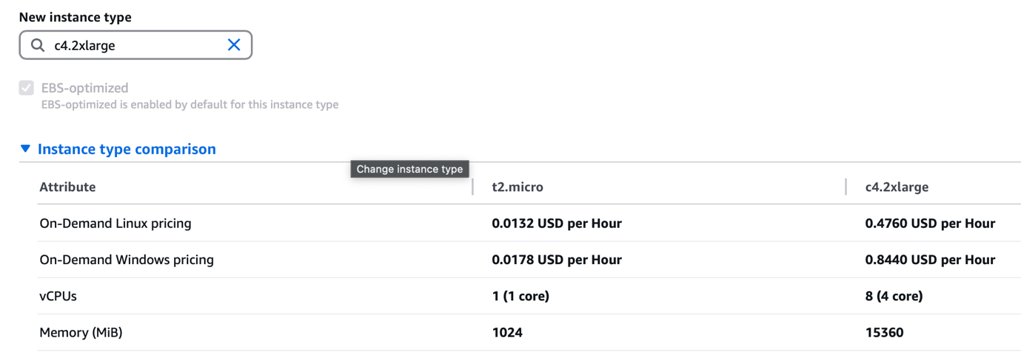

# Appendix 4: Application Local Machine Setup

The command below was used to create a new React.js project named zero-trust:

Command: npx create-react-app zero-trust cd zero-trust

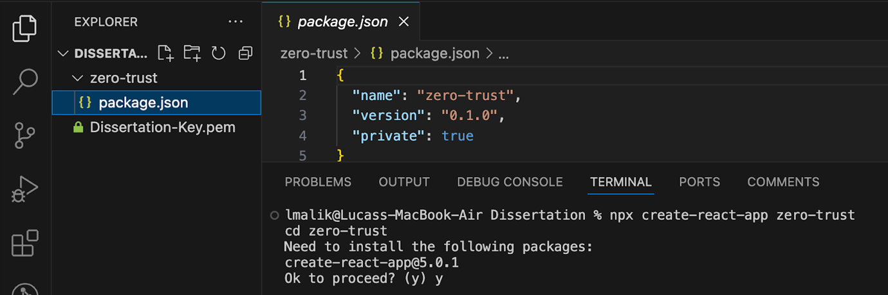

The required packages were then installed:

Command: npm install react aws-sdk amazon-cognito-identity-js

Once complete, the web server was started and accessible from (http://localhost:3000).

Command: npm start

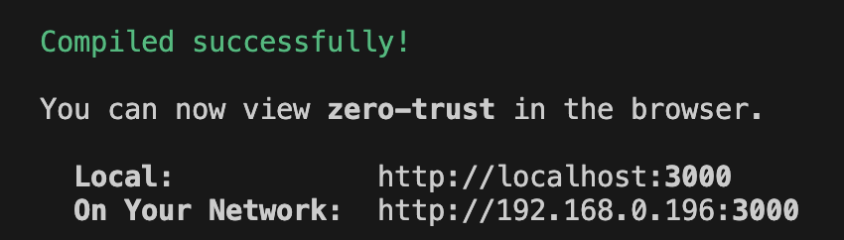

# Appendix 5: Frontend Login Interface Development

5.0.1. The early prototype below, included input fields for email and password, with a “Login” button styled in blue to visually separate interactive elements.

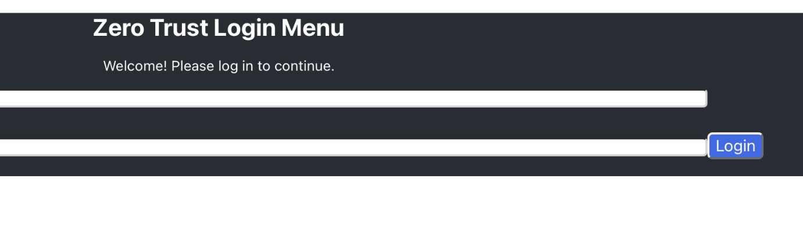

5.0.2. Another aspect considered was the appearance of error messages and validation, when a user incorrectly fills the field requirements a popup error message is returned to them. The layout also followed a minimalist structure, to reduce distractions for the user.

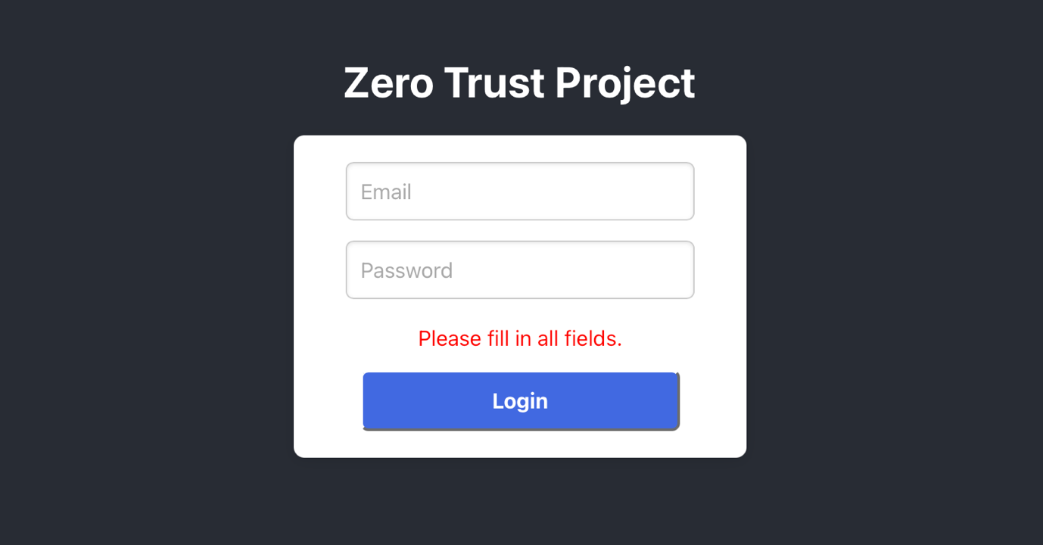

5.0.3. Global styles were defined in globalStyles.js, for consistent styling and reusable CSS-in-JS styling across various screens. Colour theming was centralised in a separate colors.js file.

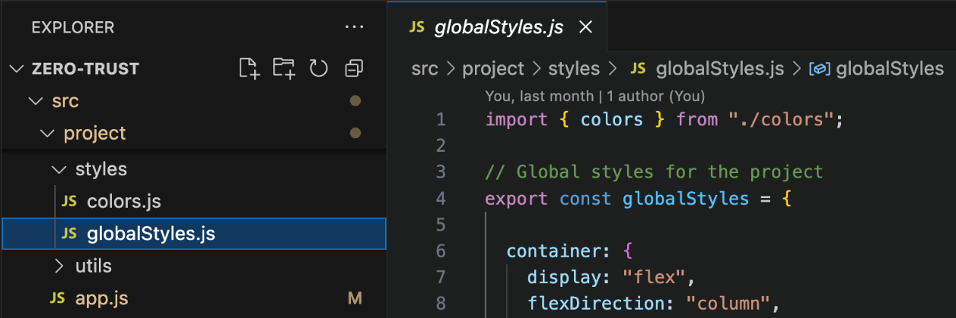

# Appendix 6: AWS IAM Groups and Users

In the screenshot below three groups were created: Admins, Developer and Regular_Users.

* Admins: Granted permissions to access most AWS services (read and write)
* Developers: Restricted to relevant services (read only)
* Regular_Users: No access permissions assigned.

Each group was assigned a single user to represent its corresponding role.

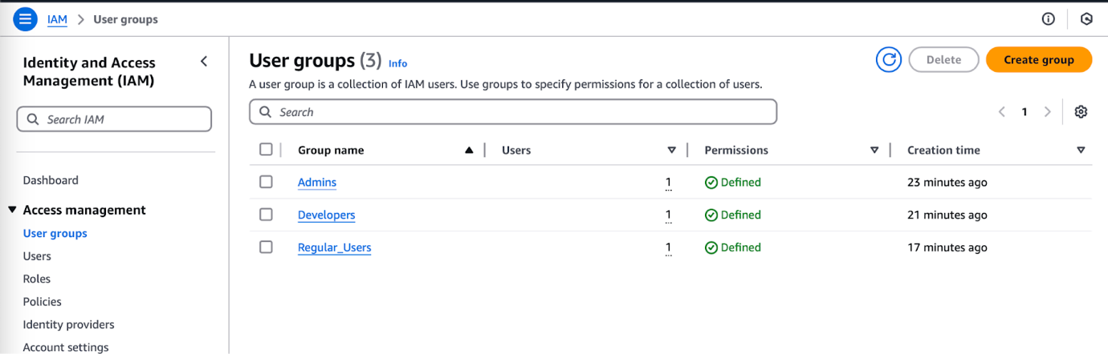

# Appendix 7: AWS Cognito Setup

In AWS Cognito a new user pool was created named Zero Trust User Pool. Allowing for user management, login authentication and MFA support for the frontend application.

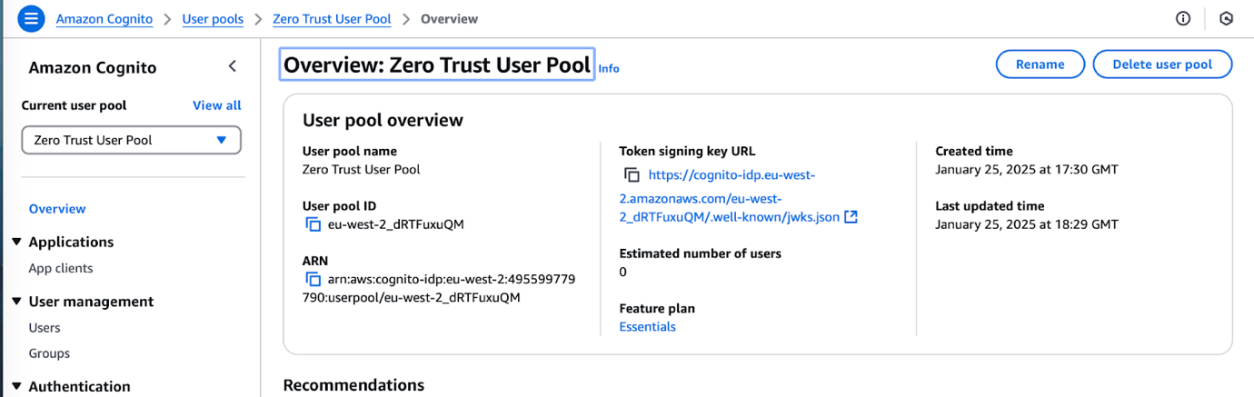

MFA was also mandated for all users, the MFA methods included: Authenticator Apps.

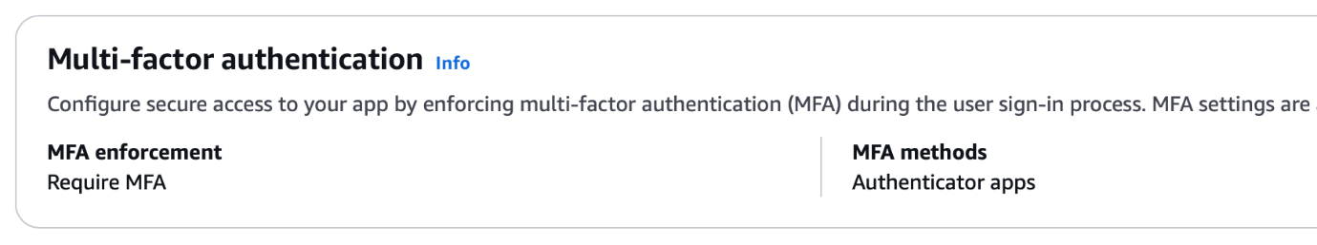

# Appendix 8: Login Functionality Development

In the screenshot below, initial testing of the login functionality revealed a configuration error related to the AWS region setting. Furthermore, MFA remained mandated, therefore users wouldn’t be able to complete the 2FA process.

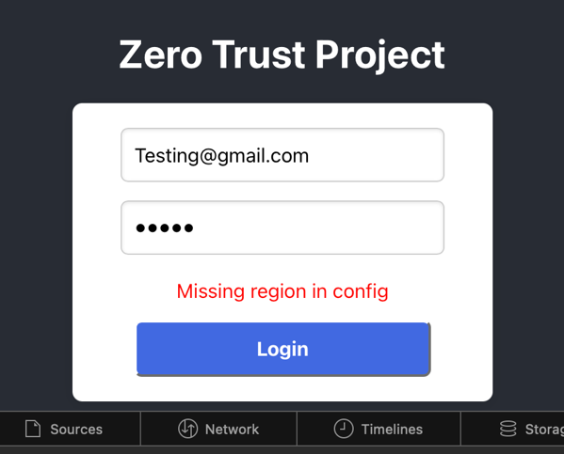

Another test was conducted after adjusting the configuration, with MFA set to optional in Cognito. This test showed that the login process was partially successful, as indicated by the message: “Login successful undefined!”

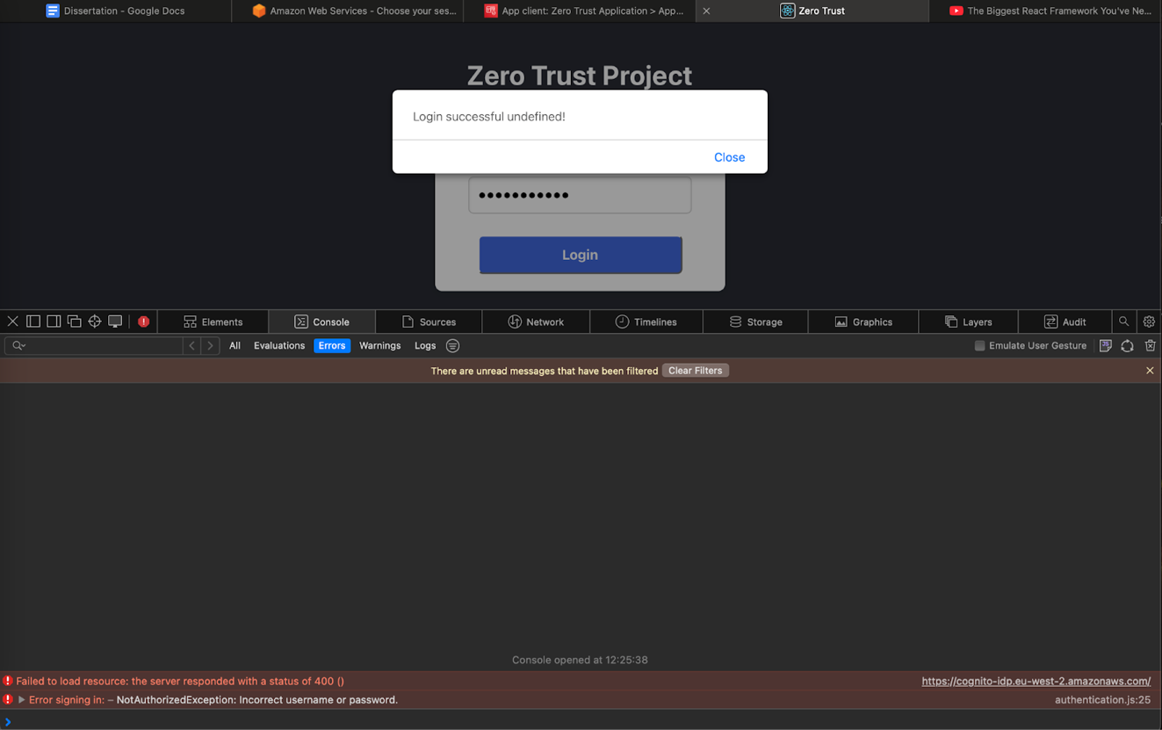

In the console logs, a challengeName “MFA_Required” was found, when MFA was reenabled, after attempting to login once again.

# Appendix 9: Email MFA Implementation

The verifyMFACode function is used to verify an MFA code (e.g. an OTP sent via email) as part of the authentication process. It interacts with AWS Cognito’s respondToAuthChallenge API to validate the code and the return the authentication result if successful.

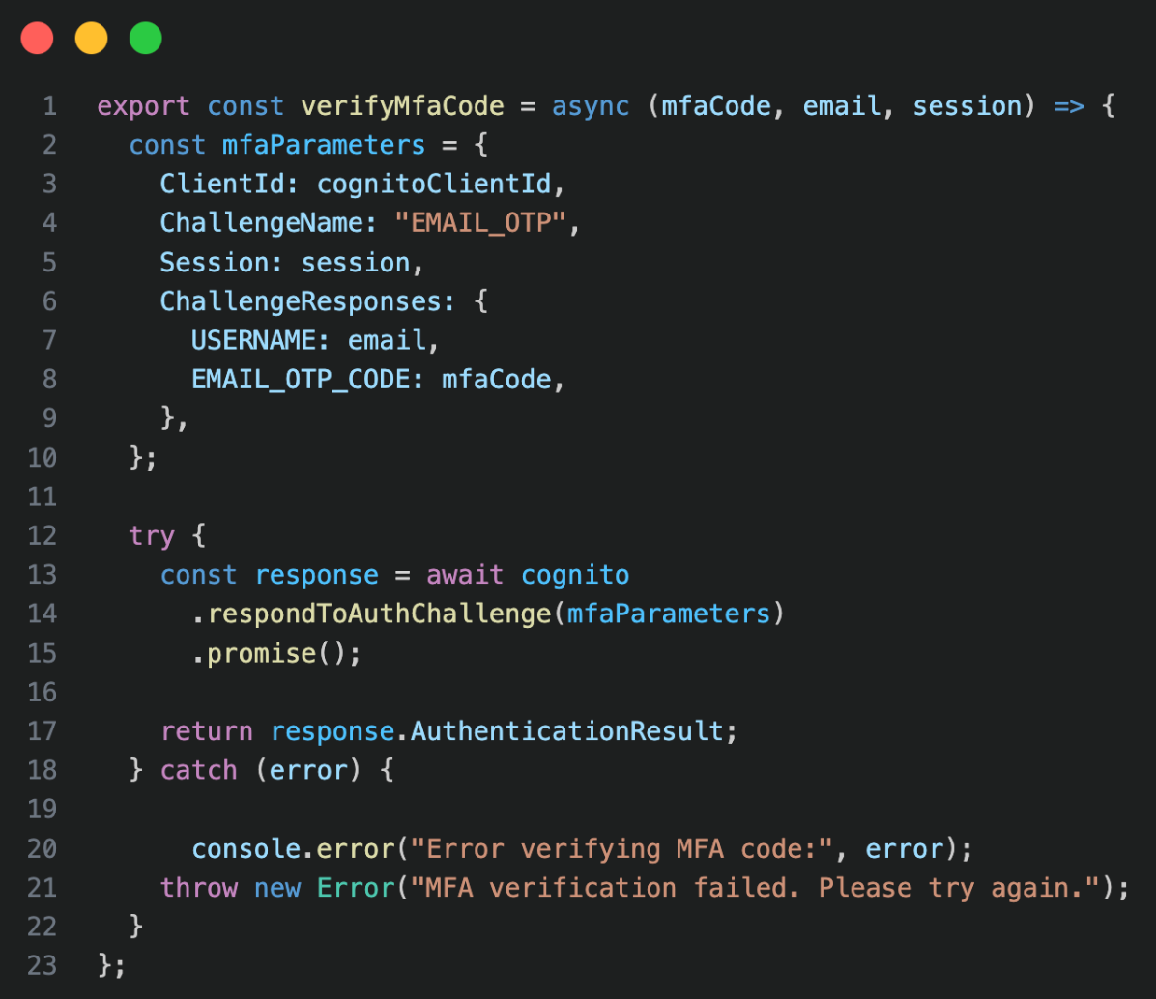

The screenshot below, is an email sent from AWS SES “Simple Email Service” to the email, zerotrustdissertation@gmail.com with an authentication code for the 2FA process.

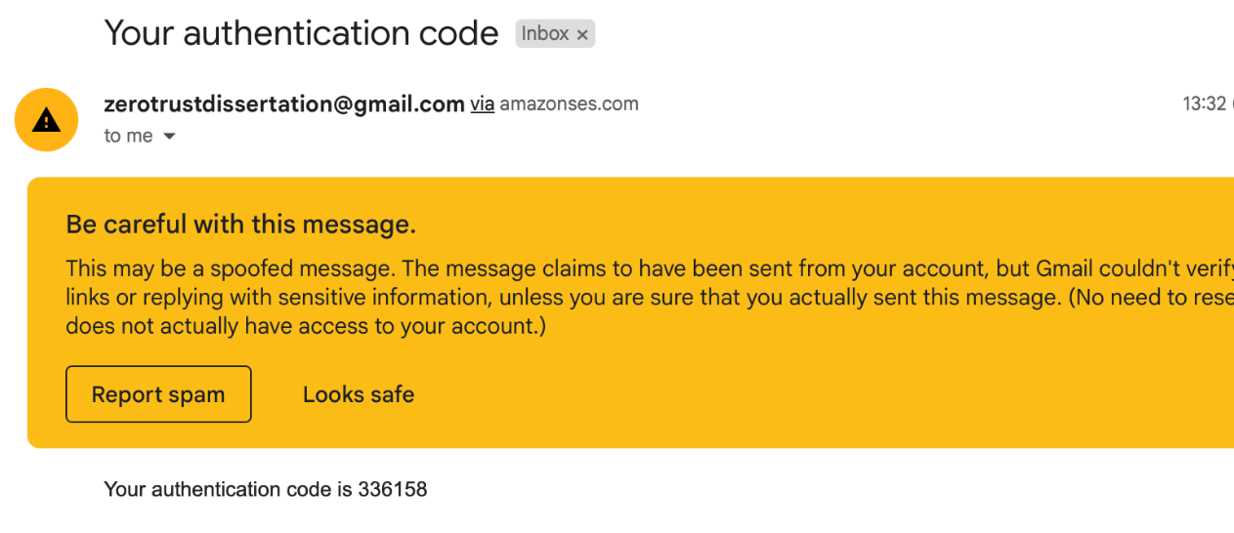

# Appendix 10: System Security Implementation

## 10.1 Environmental Variables

To securely manage secret keys or sensitive configurations details, Cognito credentials are stored in a .env file enabling for separation of secrets from the source code. The environmental variables are accessed via process.env in the frontend application, for the configuration of authentication flows. This is safer than using hardcoded variables, which are more likely to be exposed in the browser.

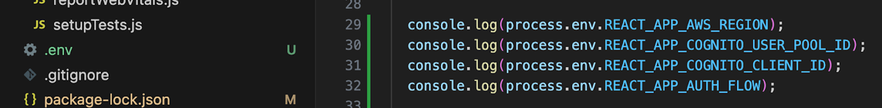

## 10.2 Secure Error Handling

To avoid exposing sensitive backend errors in production, custom error messages were implemented using an environment check. In the development environment, detailed error messages are logged using console.error() to assist with debugging. However, in production only generic messages are returned to the user.

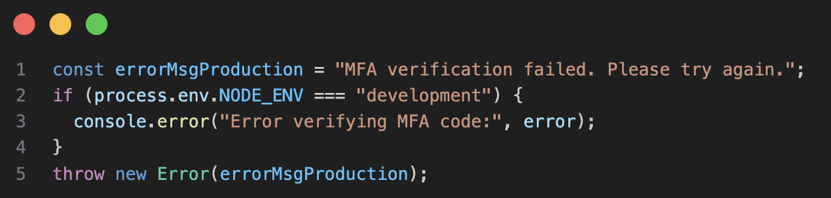

The implementation ensures that no authentication failures are leaked in a live production environment, aligning with OWASP security best practices.

## 10.3 Application Production Mode Deployment

The GitHub repository React-Frontend-Zero-Trust main branch was built and deployed to AWS Amplify, with the application accessible from the domain below in the screenshot.

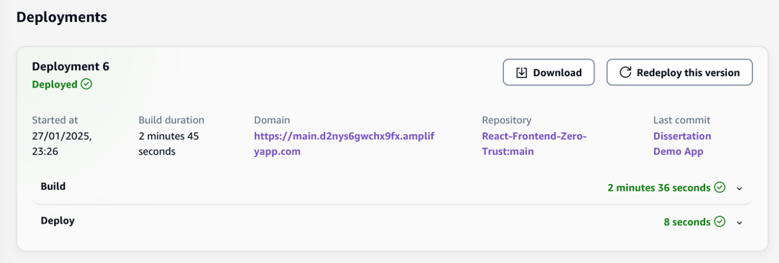

# Appendix 11: Monitoring and Threat Protection Implementation

## 11.1 Cognito Monitoring Setup

Monitoring solutions were explored, especially for Cognito to monitor user activity in the application. The plus plan in the screenshot below was identified, which allowed protection against sign in attempts, analysation of user activity from generational logs and metrics.

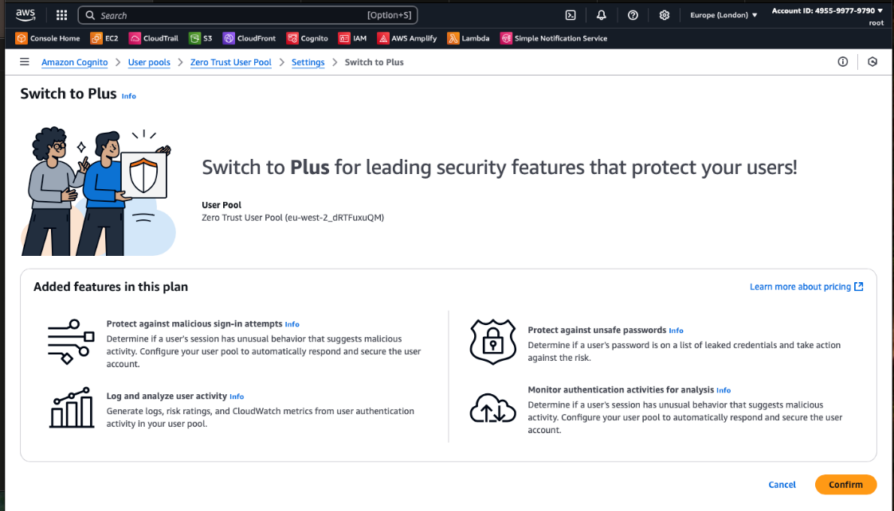

The decision was chosen to use audit-only for authentication enforcement, over tighter measures due to complexity, higher costs and risks associated with application functionality breaking.

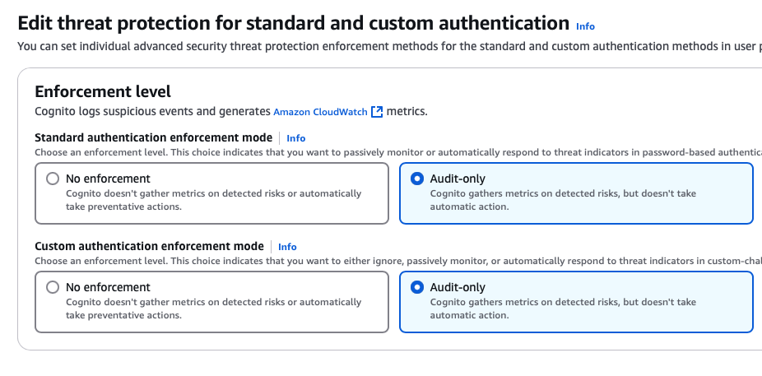

Following this, a new cloudwatch log group in the screenshot below was created named /aws/cognito/userpool/eu-west-2/, exporting user activity logs to external AWS services.

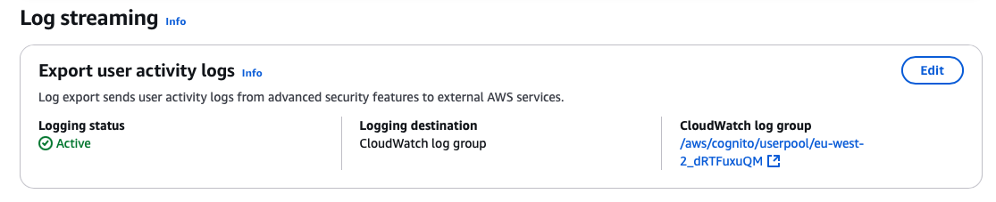

When navigating to the log group in AWS CloudWatch, authentication-related log events were retrieved. These results were related to a recent white box test and confirmed that user activity was being properly logged and monitored.

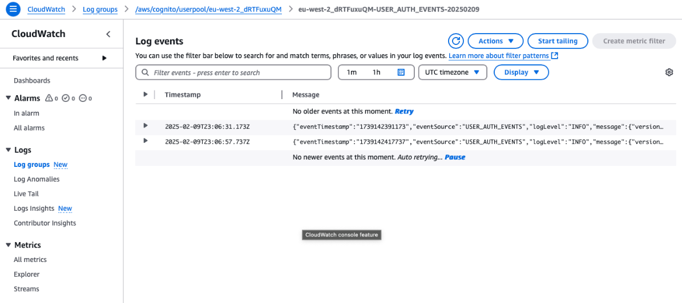

## 11.2 CloudWatch CognitoSecurityEvents Dashboard Setup

In AWS CloudWatch a new custom dashboard was created named CognitoSecurityEvents, to monitor logs events. This dashboard would be used to centralise the visibility of user authentication activities, such as sign-in attempts, MFA challenges, and anomalies related to AWS Cognito.

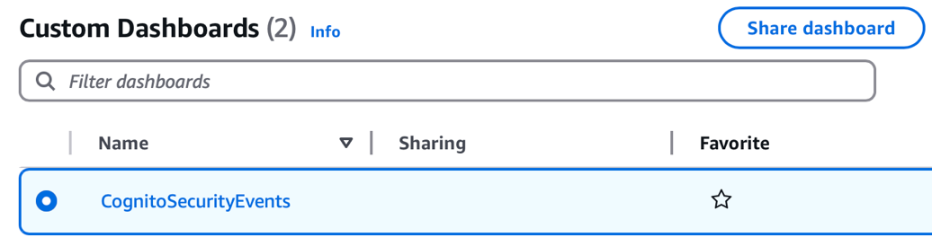

In AWS CloudWatch Log insights, a bar chart diagram was created based on filtering logs to track the sign in authentication success rate, from logs stored in a S3 Bucket.

Command: stats count(*) by message.eventResponse | filter message.eventType = "SignIn"

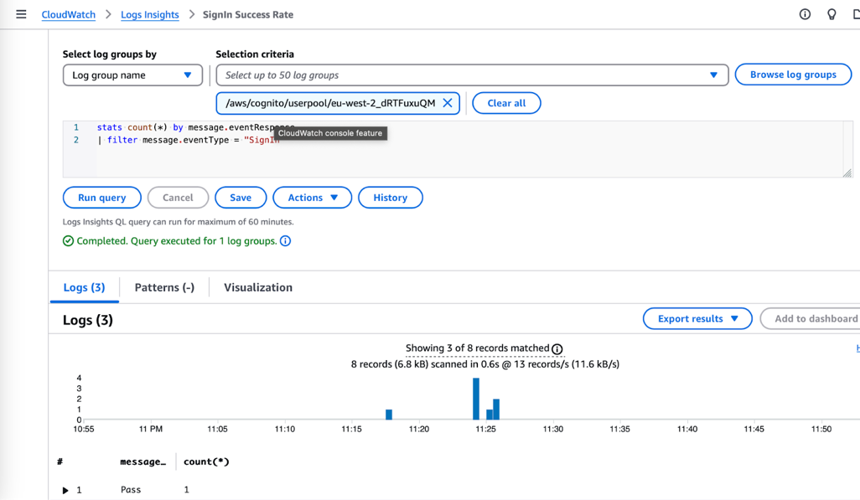

Another custom query developed below to track and log SignIn authentication information.

Command: fields *@timestamp*, message.userName, message.ipAddress, message.country, message.eventResponse, message.challenges.0, message.challenges.1

| filter message.eventType = "SignIn" | sort *@timestamp* desc

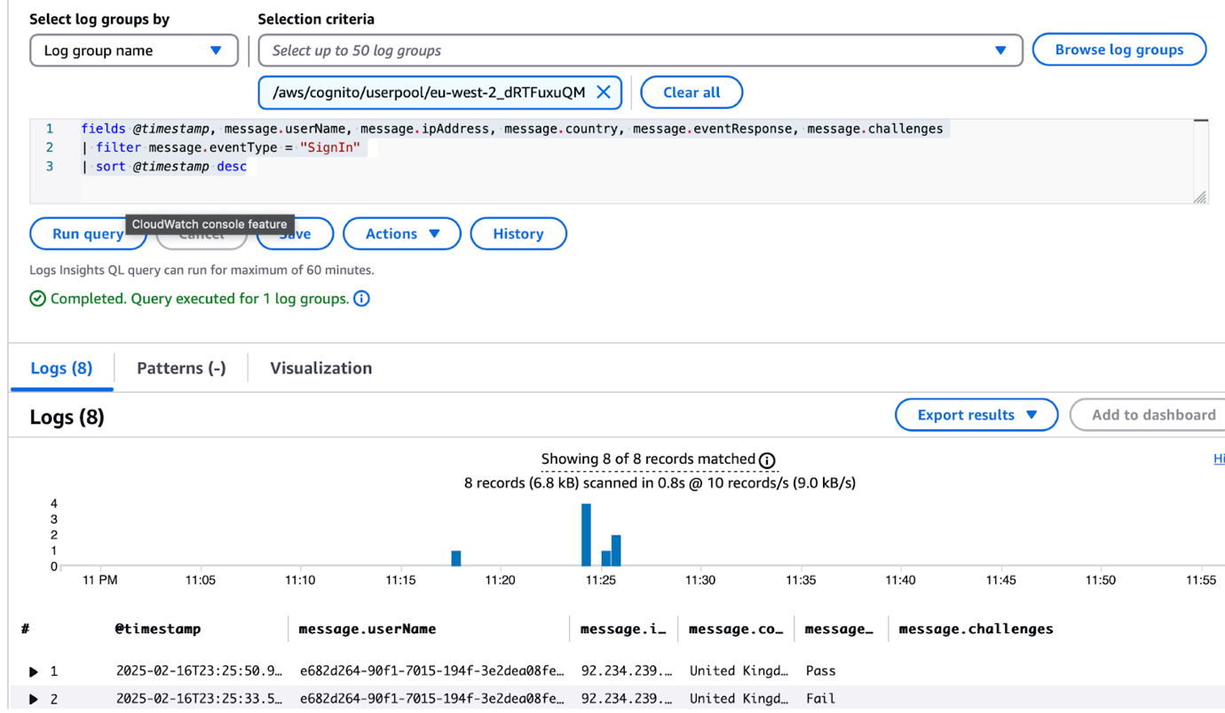

Created a metric filter named CognitoFailed Login to track the number of specific failed logins.

Command: { $.message.eventType = "SignIn" && $.message.eventResponse = "Fail" }

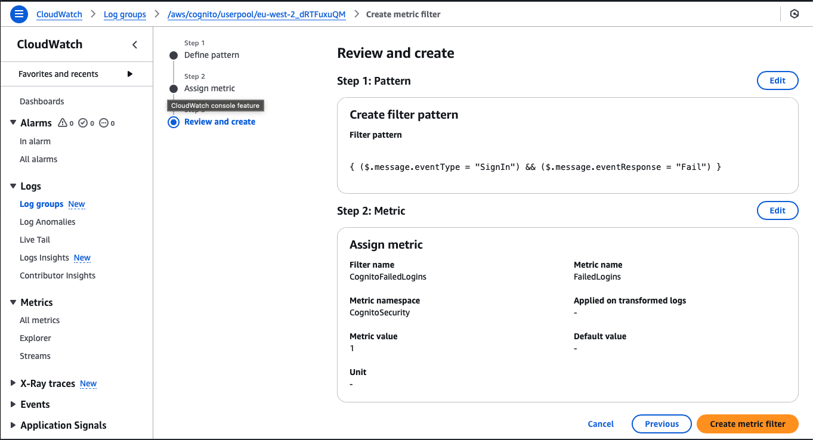

An alarm was created, to alert in a situation within a period of 5 minutes. If 4 or more failed logins are detected, an email is sent to “zerotrustdissertation@gmail.com” to notify about the warning using AWS SNS (Simple Notification Service).

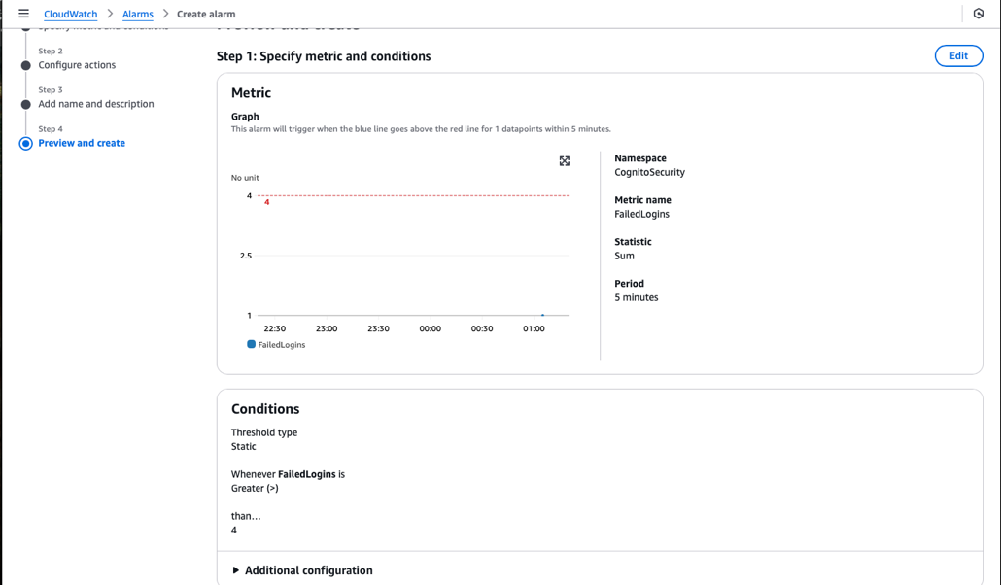

In the screenshot below, the alarm was triggered when an assessment was conducted.

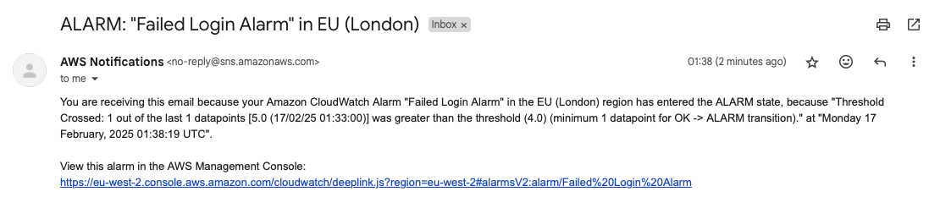

## 11.3 CloudWatch CognitoSecurityEvents Dashboard

The CognitoSecurityEvents dashboard shown below was created to visualise user login activity and authentication outcomes from AWS Cognito. The main chart, labelled Application Login Success Rate, provides an overview of recent login attempts over a specified time range. The bar chart categories login attempts into three groups:

* Pass – Successful authentications,
* Fail – Failed login attempts (e.g., incorrect password or failed MFA),
* InProgress – Partially completed logins (e.g. waiting for MFA challenge).

To the right of the bar chart, is the Failed Login Attempts Alarm. The alarm is triggered when four or more failed login attempts occur within five minutes. Upon activation, an alert is sent via email to the administrator’s email. Below the bar chart, detailed log entries are displayed showing metadata for each login attempt, including:

* *@timestamp* – login time,
* message.userName – user’s name or id,
* message.ipAddress – source IP address,
* message.country – geolocation,
* message.eventResponse – result of the authentication (Pass, Fail, InProgress),
* message.challenges – result of specific authentication challenge (e.g. password, MFA)

At the bottom of the dashboard, another events table tracks all SignOut logs, providing details about session terminations. Information includes the sign-out timestamp, the eventName and the source IP address.

These charts provide immediate visual feedback, by revealing patterns such as unusual spikes in failed logins which could indicate brute force attempts, or credential stuffing attempts.

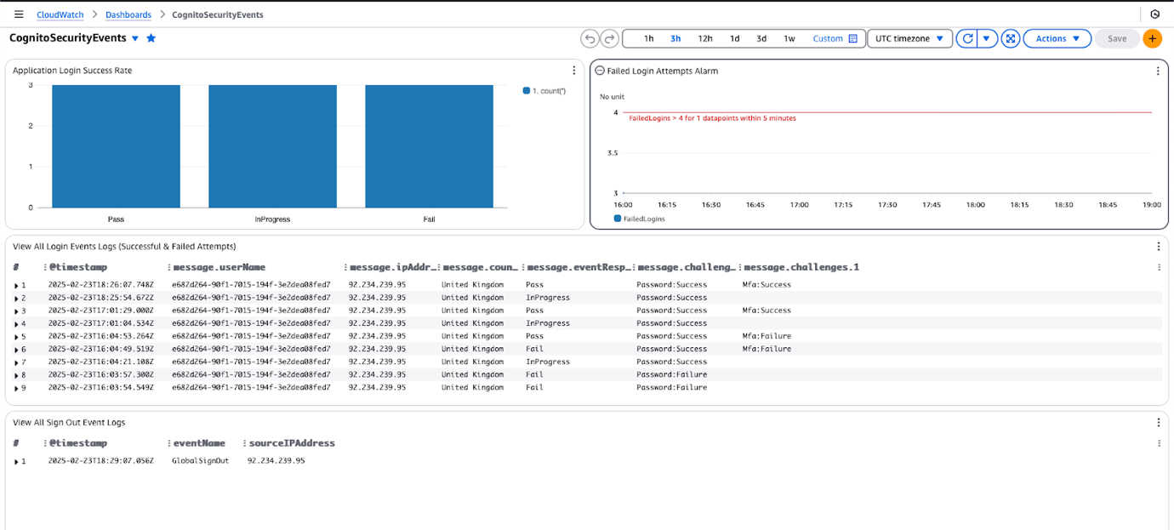

## 11.4 CloudTrail Logging Issues

Unfortunately, due to time constraints, extra costs, and complexity involved with configuring CloudTrail was excluded from the final implementation.

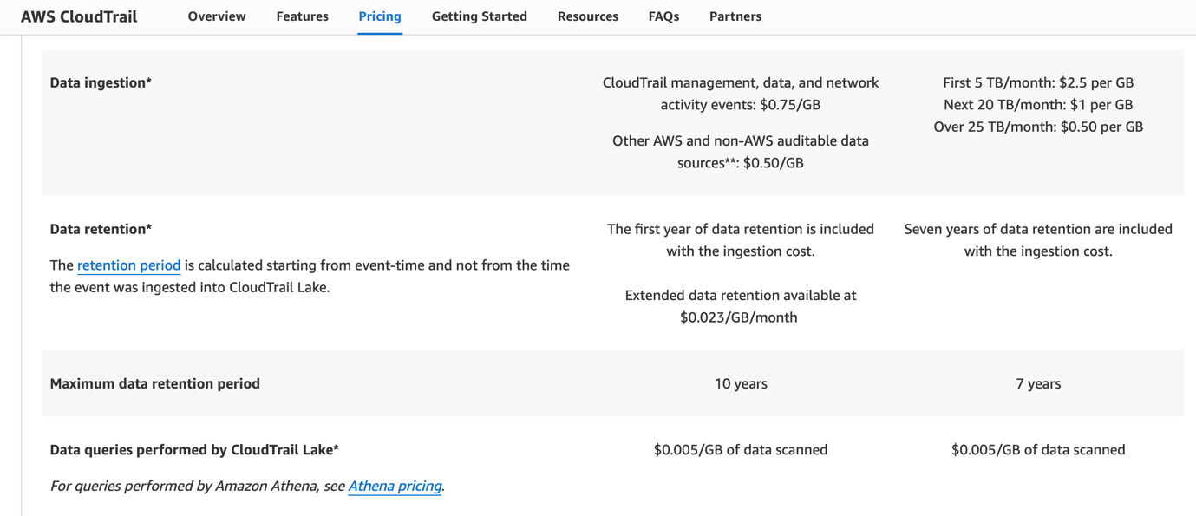

# Appendix 12: Pre-Implementation Vulnerability Assessment

## 12.1 Curl Tool Scan

The curl commands shown below were used to retrieve HTTP and HTTPS response headers of the Amplify hosted web application. These tests were conducted to verify whether traffic is properly redirected from HTTP to HTTPS, making sure that data in transit is encrypted.

Command: curl -I http://main.d2nys6gwchx9fx.amplifyapp.com/

Output:

HTTP/1.1 301 Moved Permanently

Server: CloudFront

Date: Sun, 02 Mar 2025 13:27:00 GMT

Content-Type: text/html

Content-Length: 167

Connection: keep-alive

Location: https://main.d2nys6gwchx9fx.amplifyapp.com/

X-Cache: Redirect from cloudfront

Via: 1.1 684924ebdafe5d7440f0d3505508c846.cloudfront.net (CloudFront)

X-Amz-Cf-Pop: LHR50-P2

Alt-Svc: h3=":443"; ma=86400

X-Amz-Cf-Id: q-LWBWpq4nNs38hhn1uBKorCNDeOG9TCT0J5mBHHUNRg1x4bTTvevw==

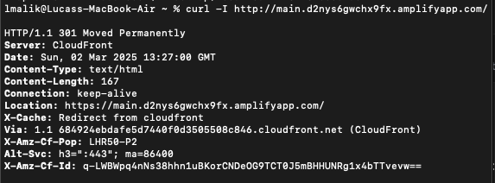

Command: curl -I https://main.d2nys6gwchx9fx.amplifyapp.com/

Output:

/

HTTP/2 200

content-type: text/html

content-length: 645

date: Sun, 02 Mar 2025 13:20:05 GMT

server: AmazonS3

accept-ranges: bytes

etag: "6f424db9535f6cf4459b5e98e9287a6d"

last-modified: Sun, 23 Feb 2025 20:22:27 GMT

cache-control: public, max-age=0, s-maxage=31536000

x-cache: Miss from cloudfront

via: 1.1 a96b4e5111339688525bc9e54ad91f88.cloudfront.net (CloudFront)

x-amz-cf-pop: LHR50-P2

alt-svc: h3=":443"; ma=86400

x-amz-cf-id: 955y8QNwiyc0ZH-qppW64kh51SCIY8nWg-vtjCGXRwN9Sn1hc2q6Kw==

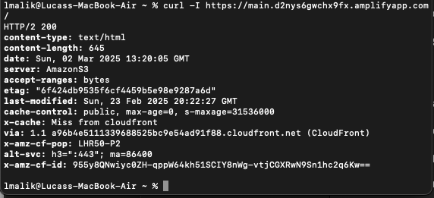

To analyse how the application responded to incorrect login attempts and whether server-side authentication routes were exposed, a curl command was used to send a POST request to the / login endpoint. The request contained a payload with an invalid username and password combination.

Command: curl -X POST "https://main.d2nys6gwchx9fx.amplifyapp.com/login" -H "Content-Type: application/json" -d '{"username":"admin", "password":"WrongPassword"}'

Output:

<!doctype html><html lang="en"><head><meta charset="utf-8"/><link rel="icon" href="/favicon.ico"/><meta name="viewport" content="width=device-width,initial-scale=1"/><meta name="theme-color" content="#000000"/><meta name="description" content="Web site created using create-react-app"/><link rel="apple-touch-icon" href="/logo192.png"/><link rel="manifest" href="/manifest.json"/><title>Zero Trust</title><script defer="defer" src="/static/js/main.35fd4e9a.js"></script><link href="/static/css/main.e6c13ad2.css" rel="stylesheet"></head><body><noscript>You need to enable JavaScript to run this app.</noscript><div id="root"></div></body></html>%

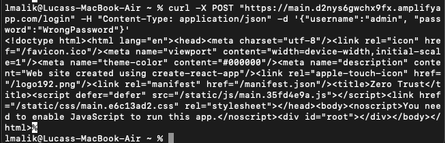

Detailed Findings:

The curl scans validate that the web application hosted is enforcing HTTPS by default. When a HTTP request was made to the site http://main.d2nys6gwchx9fx.amplifyapp.com/, the server responded with a 301 Moved Permanently status code, redirecting the request to the https:// endpoint. This confirmed that automatic redirection from HTTP to HTTPS was enabled, preventing unencrypted transmission of information.

Further analysis of the HTTPS response headers showed that the site returned a 200 OK status was served via Amazon S3 and CloudFront. Security headers such as cache-control, alt-svc were present, and TLS was enforced via the HTTP/2 protocol. No critical security headers like Strict-Transport-Security “HSTS” or Content-Security-Policy “CSP” were observed.

The POST request test indicated that the application does not have a /login endpoint at the server level. Instead, HTML content at the frontend was returned, showed that a react app was in use. Suggesting that login functionality was entirely handled on the client-side using AWS Cognito and JS libraries (e.g. amazon-cognito-identity-js). Therefore, no server endpoints are available meaning no risks of credential stuffing or brute force attacks via this route.

## 12.2 Nmap Tool Scan

The nmap command below was executed to scan the status of ports 80 (HTTP) and 443 (HTTPS) for the web server.

Command: nmap -p 80,443 main.d2nys6gwchx9fx.amplifyapp.com

Output:

Starting Nmap 7.95 ( https://nmap.org ) at 2025-03-02 13:45 GMT

Nmap scan report for main.d2nys6gwchx9fx.amplifyapp.com (108.156.46.53)

Host is up (0.020s latency).

Other addresses for main.d2nys6gwchx9fx.amplifyapp.com (not scanned): 108.156.46.113 108.156.46.29 108.156.46.33

rDNS record for 108.156.46.53: server-108-156-46-53.lhr50.r.cloudfront.net

PORT    STATE SERVICE

80/tcp  open  http

443/tcp open  https

Nmap done: 1 IP address (1 host up) scanned in 0.13 seconds

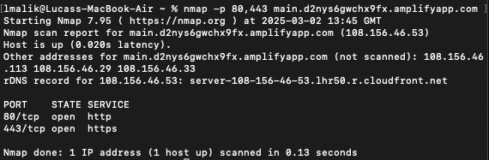

Detailed Findings:

The scan results confirm that both HTTP (Port 80) and HTTPS (Port 443) are open and accessible on the target domain. No unexpected or unnecessary open ports were found reducing the potential attack surface.

## 12.3 OWASP ZAP Vulnerability Scan

An OWASP ZAP scan was performed on https://main.d2nys6gwchx9fx.amplifyapp.com on 2nd March 2025, to identify potential vulnerabilities in the application prior to final security hardening. The scan used both passive and active techniques.

Target: https://main.d2nys6gwchx9fx.amplifyapp.com

Included Risks: High, Medium, Low, Informational.

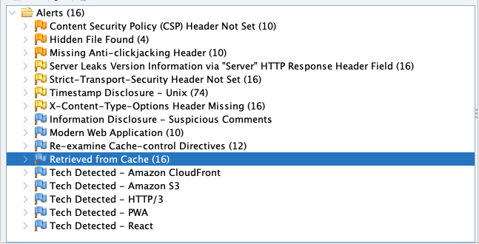

### 12.3.1 Key Detailed Findings of OWASP ZAP Vulnerability Scan

|  |  |  |  |  |  |
| --- | --- | --- | --- | --- | --- |
| Alert Type | Risk | Location | Description | Mitigation | References |
| Content Security Policy (CSP) Header Not Set | Medium | https://main.d2nys6gwchx9fx.amplifyapp.com/sitemap.xml | CSP adds an extra layer of security, to prevent attacks such as Cross Side Scripting (XSS) and code injection. | Configure the web server to have a CSP header. | https://developer.mozilla.org/en-US/docs/Web/HTTP/Guides/CSP |
| Missing Anti-clickjacking Header | Medium | https://main.d2nys6gwchx9fx.amplifyapp.com/sitemap.xml | No protection against Clickjacking attacks. A malicious actor can manipulate UI elements. | Include X-Frame-Options ‘Deny’ or a CSP Header: frame ancestors. | https://owasp.org/www-project-web-security-testing-guide/v42/4-Web_Application_Security_Testing/11-Client-side_Testing/09-Testing_for_Clickjacking |
| Hidden File Found | Medium | https://main.d2nys6gwchx9fx.amplifyapp.com/.hg | Hidden version control file found, could reveal sensitive data (e.g. Source Code & Credentials). | Ensure no development files are located in production builds. | https://cwe.mitre.org/data/definitions/538.html |
| Strict-Transport-Security Header Not Set | Low | https://main.d2nys6gwchx9fx.amplifyapp.com/sitemap.xml | The HSTS Header is missing, could allow for browsers to interact with insecure HTTP sessions, susceptible to MITM attacks etc. | Set Strict-Transport-Security header to force HTTPS only communication. | https://cwe.mitre.org/data/definitions/319.html |

## 12.4 CloudWatch Dashboard Logs and Alarm

The CognitoSecurityEvents dashboard was tested to ensure that all user activity was accurately tracked. This included verification of bar charts, login attempts, sign-outs and triggered alarms.

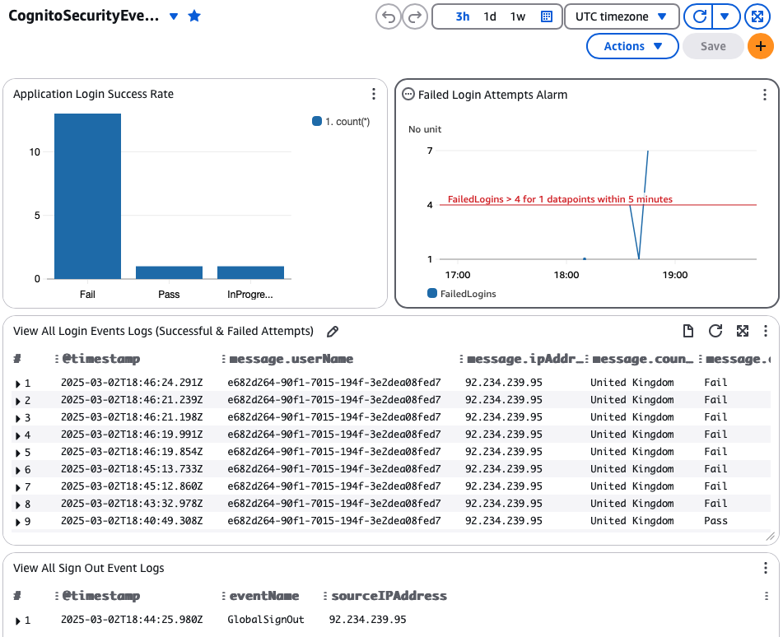

Detailed Findings:

User activity logs, visual diagrams and alarms operated as expected. However, the application remains partially vulnerable to brute force attacks, as only short duration lockout policies are enforced by default. Some improvements could involve further monitoring of user actions, stricter enforcement of threat protection over solely relying on audit-only mode. The integration of a firewall-based system such as AWS WAF “Web Application Firewall” to mitigate automated attack patterns and limit region traffic.

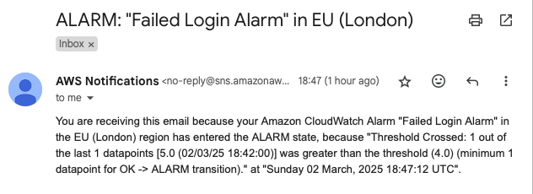

## 12.5 IAM Groups, Users, and Policies

Every group, user and permission policies assigned were reviewed to ensure least privilege access.

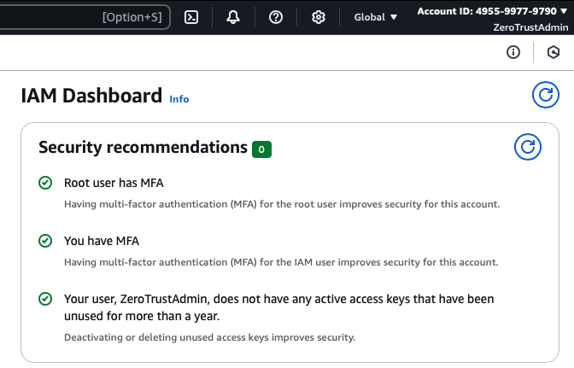

Detailed Findings:

In the screenshot above, security recommendations confirm that administrator user privileges were correctly assigned, with MFA mandated. However, the ZeroTrustDeveloper user retained administrator privileges, raising additional concerns as older access keys remained active for this account. This presented a potential security risk. Future improvements could also include enabling AWS CloudTrail logging for all IAM user actions in the AWS console.

# Appendix 13: Security Hardening

## 13.1 Custom Headers Amplify and IAM Users

Custom Headers were added to Amplify, each one structured as a key-value pair.

* Strict-Transport-Security - Prevents HTTPS downgrade attacks.
* Content-Security-Policy - Helps prevent XSS “Cross-Site Scripting”.
* X-Frame-Options - Prevents Clickjacking.
* X-Content-Type-Options - Prevents MIME-type sniffing.
* Referrer-Policy - Controls how referrer information is sent.

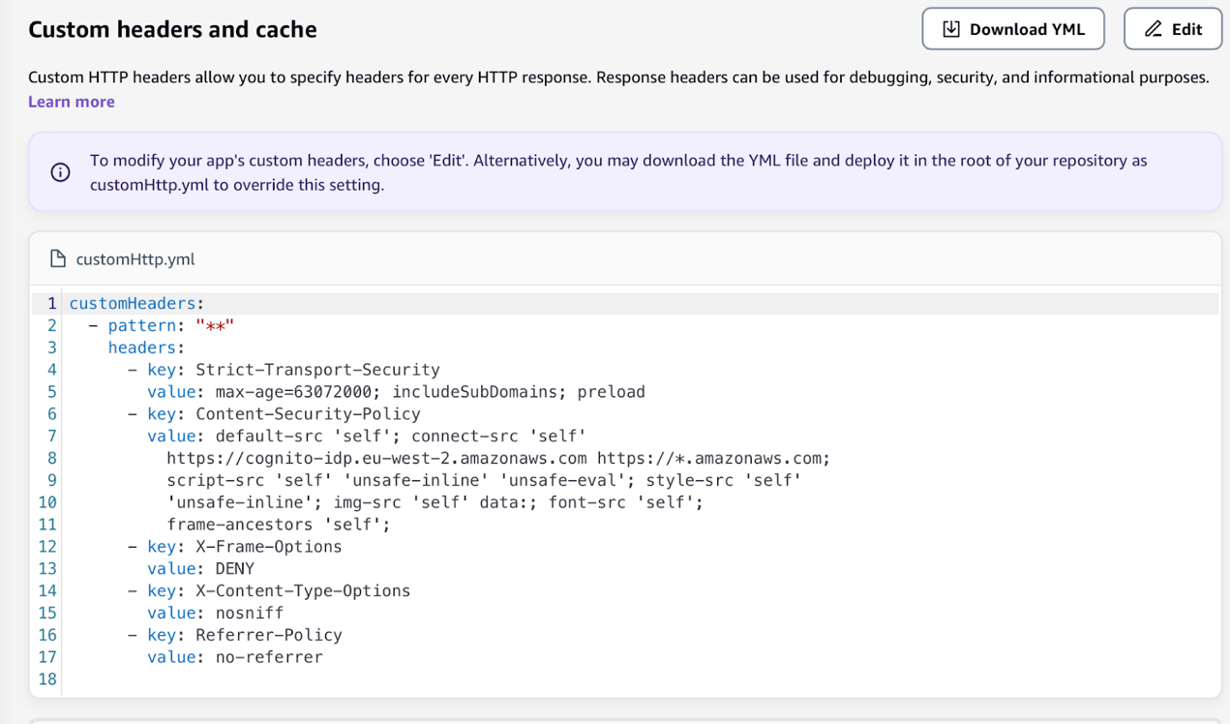

The IAM User ZeroTrustDeveloper permission policy name AdministratorAccess was removed, old unused access keys removed from Security credentials.

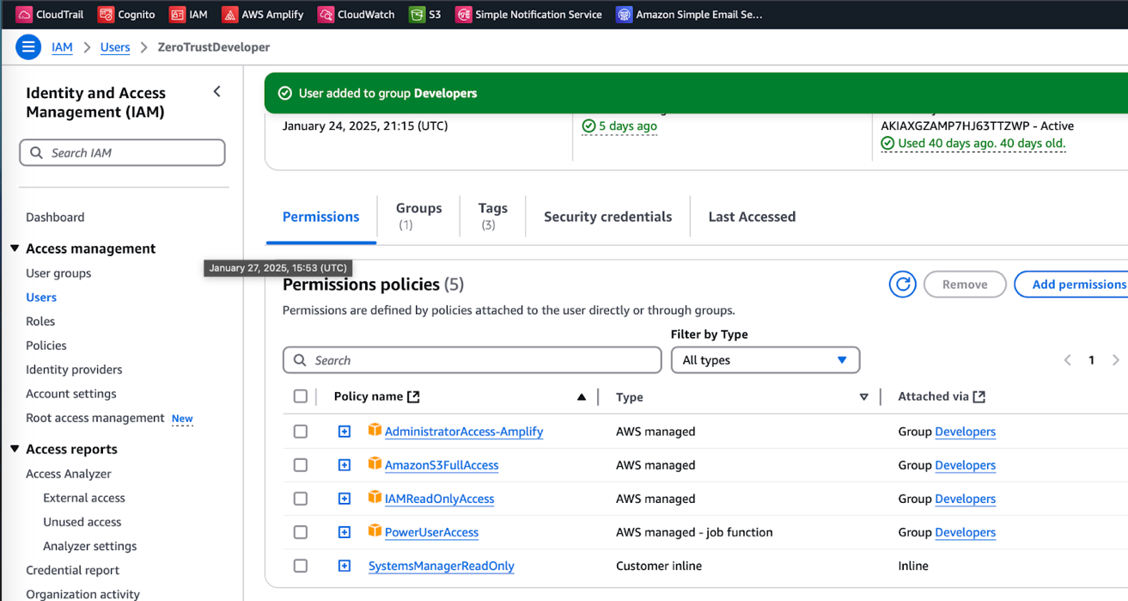

## 13.2 React Application Routing and Navigation Rework

The routing and navigation system was reworked for the React application using the react-router-dom module. The auth route allows for unauthenticated users to access screens in the AuthNavigator component (login, mfa, totp-setup); if an authenticated user attempts to navigate to these screens logged in, the GuestRoute component redirects them back to the dashboard. In the contrary, for the dashboard route authenticated users can access screens in the DashboardNavigator (menu). If a malicious actor were to navigate to here, the ProtectedRoute component redirects them back to the authentication flow.

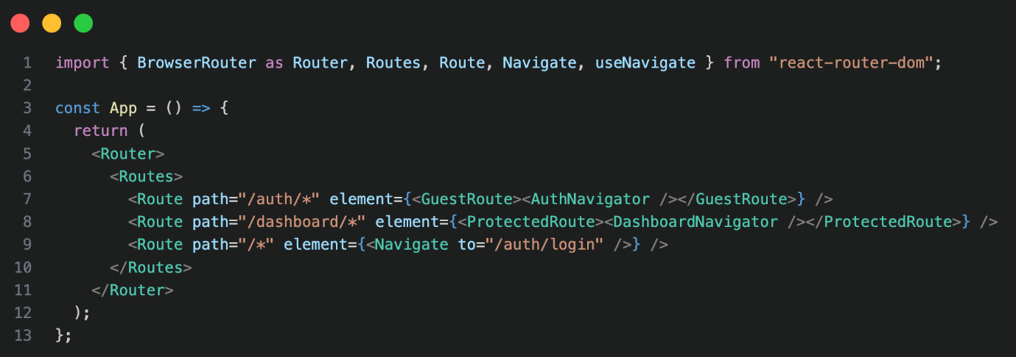

## 13.3 TOTP Authentication Implementation

These functions below were created to handle the TOTP setup and verification process in AWS Cognito.

* associateTOTP – Generates the secret TOTP code for the QR code.
* verifyTOTP – Confirms whether the user’s input code is valid.

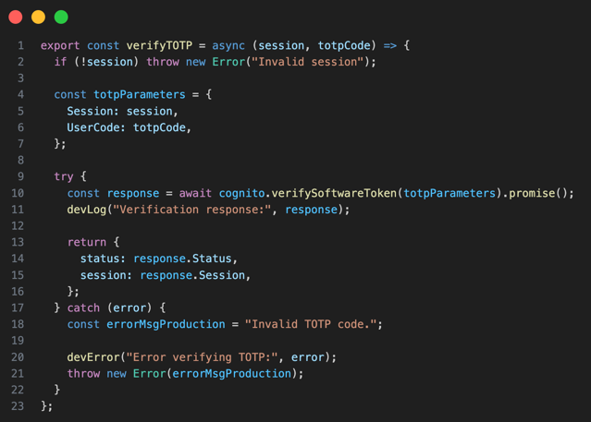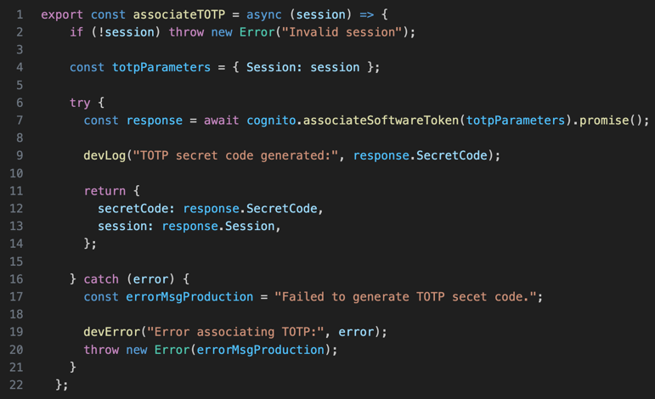

## 13.4 TOTP Authentication Setup Step-By-Step Process

The administrator in the AWS console can create a new user within Cognito. Once created, the user can sign in with their assigned username and password. Following this, the user is prompted to setup TOTP authentication on a device app (e.g. Google Authenticator) by scanning the given QR code. The TOTP code generated in the user’s authenticator app of choice can be used to verify and enable TOTP by inputting the MFA code in the website browser. Once completed users can login via the 2FA process.

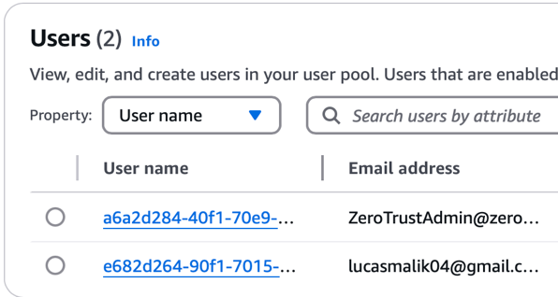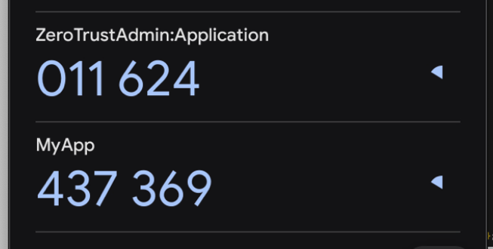

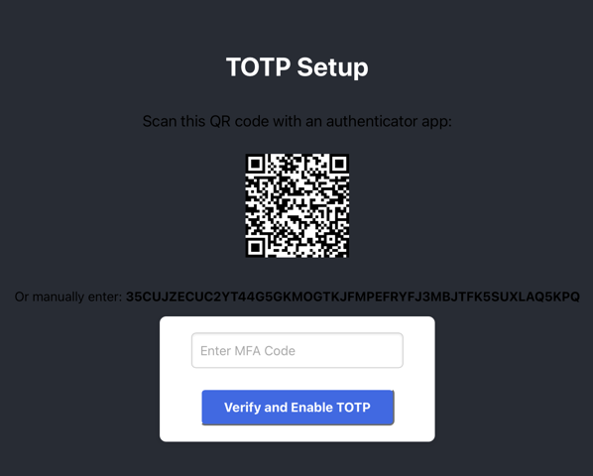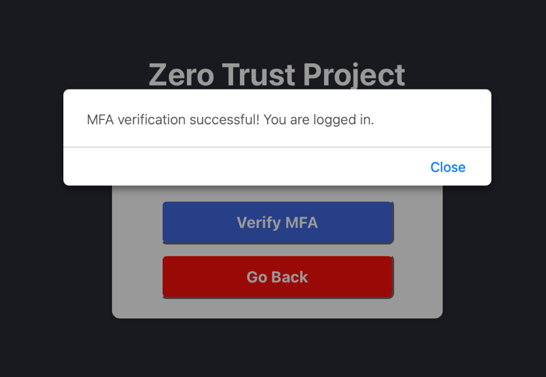

# Appendix 14: Post-Implementation Vulnerability Assessment

## 14.1 OWASP ZAP Vulnerability Scan (2nd Run)

A second OWASP ZAP scan was performed on https://main.d2nys6gwchx9fx.amplifyapp.com on 28th March 2025, to identify any remaining or newly introduced vulnerabilities in the application after applying security improvements. The scan used both passive and active techniques.

Target: https://main.d2nys6gwchx9fx.amplifyapp.com

Included Risks: High, Medium, Low, Informational.

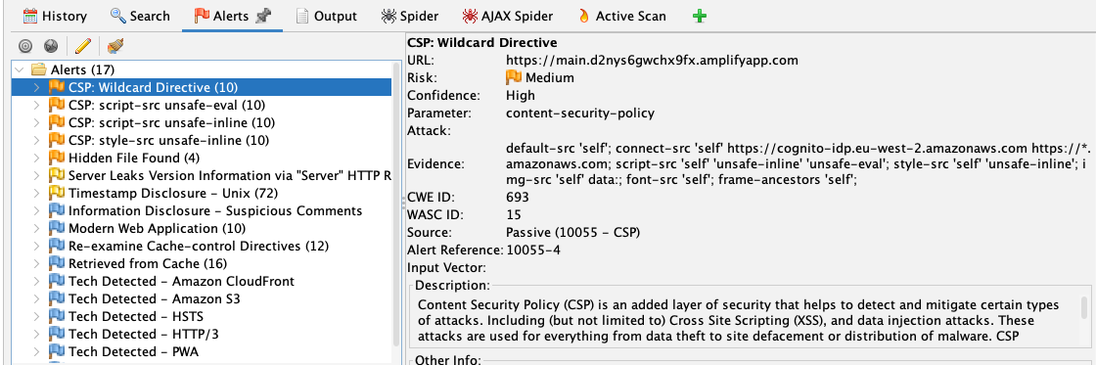

## 14.1.1 Key Detailed Findings of OWASP ZAP Vulnerability Scan (2nd Run)

|  |  |  |  |  |  |
| --- | --- | --- | --- | --- | --- |
| Alert Type | Risk | Location | Description | Mitigation | References |
| CSP: Wildcard Directive | Medium | https://main.d2nys6gwchx9fx.amplifyapp.com | Missing e.g. ‘form-action’ wildcard directives, without it allows for form data to be submitted to untrusted sources. | Revise the CSP policy to include ‘form-action’, ‘script-src’, ‘style-src’ etc. | https://cwe.mitre.org/data/definitions/693.html |
| CSP: script-src unsafe-eval | Medium | https://main.d2nys6gwchx9fx.amplifyapp.com | Includes the ‘unsafe-eval’ directive under ‘script-src’, allows the use of eval() and similar JS functions. Using eval() can execute arbitrary code if exploited from a XSS vulnerability. | Remove the “unsafe-eval” keyword from the CSP. | https://www.w3.org/TR/CSP/ |
| CSP: script-src & style-src unsafe-inline | Medium | https://www.w3.org/TR/CSP/ | ‘Unsafe-inline’ is located under the ‘script-src’ and ‘style-src’ directives. Permits the execution of inline JS/CSS within HTML documents. | Replace “unsafe-inline” with nonce or hashed-based policies. | https://www.w3.org/TR/CSP/ |
| Hidden File Found | Medium | https://main.d2nys6gwchx9fx.amplifyapp.com/.hg | Hidden version control file found, could reveal sensitive data (e.g. Source Code & Credentials). | Ensure no development files are in production builds. | https://cwe.mitre.org/data/definitions/538.html |

## 14.2 Curl Tool Scan (2nd Run)

The curl commands shown below were ran once again to retrieve HTTP and HTTPS response headers of the Amplify hosted web application.

Command: curl -I [http://main.d2nys6gwchx9fx.amplifyapp.com/](https://main.d2nys6gwchx9fx.amplifyapp.com/)

Output:

HTTP/1.1 301 Moved Permanently

Server: CloudFront

Date: Sat, 29 Mar 2025 18:01:47 GMT

Content-Type: text/html

Content-Length: 167

Connection: keep-alive

Location: https://main.d2nys6gwchx9fx.amplifyapp.com/

X-Cache: Redirect from cloudfront

Via: 1.1 8f6304f833570c94da896f597bd3ccde.cloudfront.net (CloudFront)

X-Amz-Cf-Pop: LHR50-P2

Alt-Svc: h3=":443"; ma=86400

X-Amz-Cf-Id: XN97Pb0MPMS-e_aCB3okCAa2UVYX5Ej459-WEgh4kCTkrDpk5WmABQ==

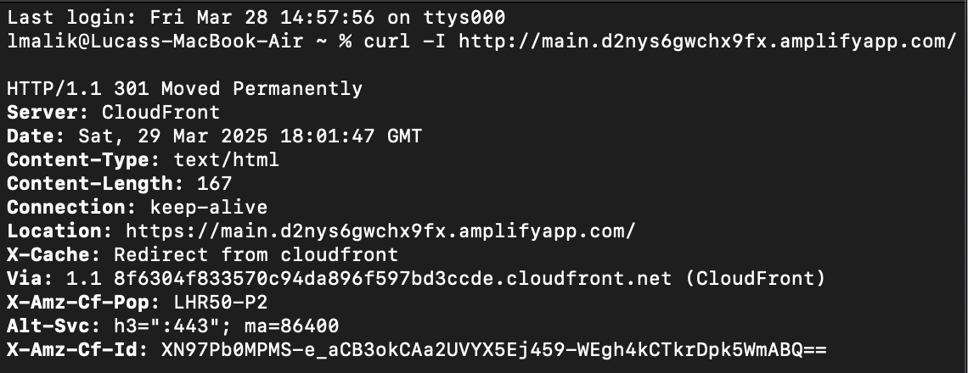

Command: curl -I <https://main.d2nys6gwchx9fx.amplifyapp.com/>

Output:

/

HTTP/2 200

content-type: text/html

content-length: 645

date: Sat, 29 Mar 2025 15:41:59 GMT

server: AmazonS3

accept-ranges: bytes

etag: "b13f48d0c720f14fbe7af92c7bbf0e3c"

last-modified: Sun, 23 Mar 2025 23:03:49 GMT

cache-control: public, max-age=0, s-maxage=31536000

strict-transport-security: max-age=63072000; includeSubDomains; preload

content-security-policy: default-src 'self'; connect-src 'self' https://cognito-idp.eu-west-2.amazonaws.com https://*.amazonaws.com; script-src 'self' 'unsafe-inline' 'unsafe-eval'; style-src 'self' 'unsafe-inline'; img-src 'self' data:; font-src 'self'; frame-ancestors 'self';

x-frame-options: DENY

x-content-type-options: nosniff

referrer-policy: no-referrer

x-cache: Hit from cloudfront

via: 1.1 2930f20ca11cde7e5f2d83d9ea84806e.cloudfront.net (CloudFront)

x-amz-cf-pop: LHR50-P2

alt-svc: h3=":443"; ma=86400

x-amz-cf-id: pKflNw6bqnq_czInabmBpRQQVs6cuaskYm6OBcbxZR-4baT6QXHcRQ==

age: 8404

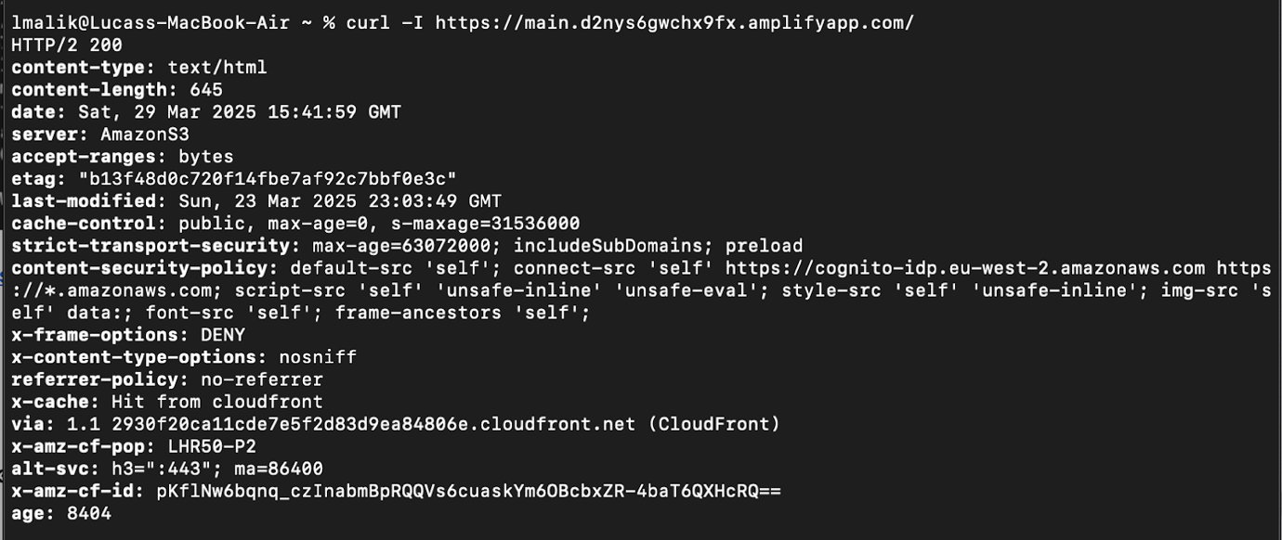

Detailed Findings:

The curl scans conducted once again, found that HSTS is enforced by the Strict-Transport-Security header, telling browsers to always use HTTPS. The CSP policy is present however is using unsafe directives (“unsafe-inline”, “unsafe-eval”) as found in the OWASP SCAN in appendix 14.1.1. Other security headers are present such as X-frame-options, x-content-type-options, and Referrer-Policy to protect against various client-side threats.

## 14.3 Nmap Tool Scan (2nd Run)

The nmap command below was executed again to scan the status of ports 80 (HTTP) and 443 (HTTPS) for the web server.

Command: nmap -p 80,443 main.d2nys6gwchx9fx.amplifyapp.com

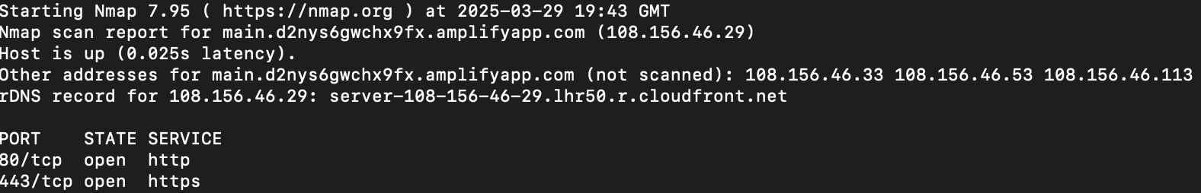

Detailed Findings:

The scan results were identical to the first Nmap scan in appendix 12.2. Both HTTP (Port 80) and HTTPS (Port 443) were open and accessible on the target domain. No unexpected ports were detected.

## 14.4 IAM Groups, Users, and Policies

Every group, user and permission policies assigned were reviewed again to ensure least privilege access.

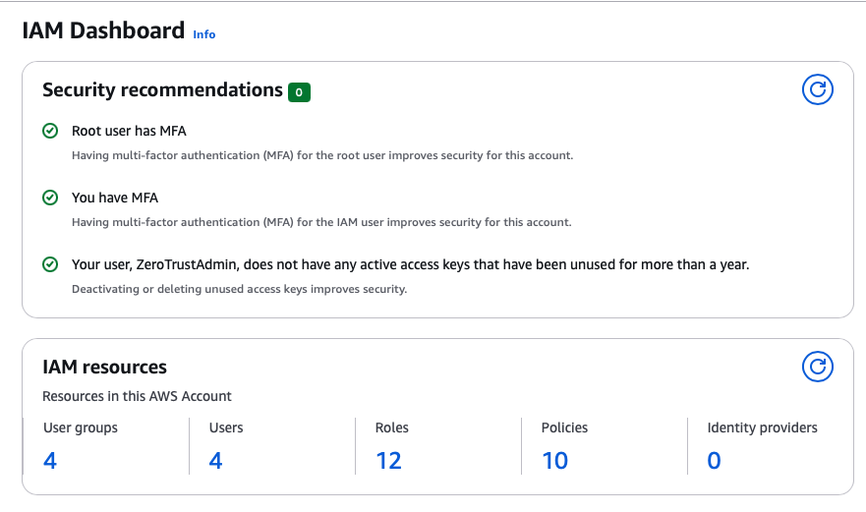

Detailed Findings:

Security recommendations are shown as healthy. Every group and user has least privilege access, with MFA enforced. The ZeroTrustDeveloper user no longer has unused access keys. However, no CloudTrail logging was implemented. This could result in users performing unauthorised actions in the AWS portal, if an account were to be compromised.

## 14.5 Website Authentication Security (2nd Run)

The application’s security was tested to assess its effectiveness. By testing different components like the login flow, navigation and error handling.

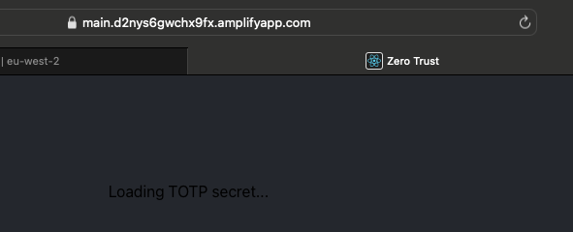

Detailed Findings:

If users were not signed in and tried to access the dashboard area. They would be redirected back to the /auth/login route. In addition, due to no navigation routing protection on the pages /totp-setup and /mfa. Users could access these pages despite their being error handling in place. To prevent this data in memory storage or a session-based value could be used to determine whether a user has authorized access or not.

Furthermore, another issue was identified. Local sessions would not automatically expire while a user was signed in. Therefore, this was a concerning risk potentially allowing a malicious actor to gain access, if a user’s device were to be compromised. Despite these concerns, users are able to sign out manually returning them to the login flow.

## 14.6 CloudWatch Dashboard Logs and Alarm (2nd Run)

The CognitoSecurityEvents dashboard was tested again to ensure that all user activity was accurately tracked. This included verification of bar charts, login attempts, sign-outs and triggered alarms. However, session tracking was not implemented, resulting in a potential blind spot in monitoring for user sessions and detecting session hijacking attempts.

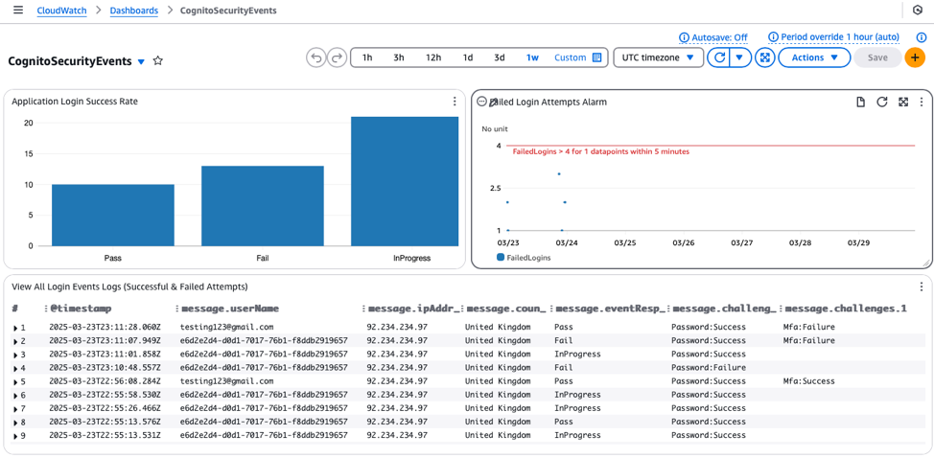

# Appendix 15: Project Diary Logs

## 15.1: Diary Log 1 (20/11/2024)

**Student: Lucas Malik (22806287) Supervisor’s signature:**

**Date: 20/11/2024 Last diary date: 20/11/2024**

**Objectives: Dissertation Proposal (Review)**

|  |
| --- |
| * Clarify whether the research question is valid for the dissertation: How can Zero Trust principles, implemented through Identity and Access Management (IAM) and Multi-Factor Authentication (MFA) in AWS, reduce unauthorised access in cloud-based web applications, and what measurable reductions in security incidents can be achieved? * Gain feedback on the project proposal and whether the practical approach of an EC2-hosted instance for a cloud application is valid. * Questions relating to university benefits or funding for the project with AWS Services. |

**Progress:**

|  |
| --- |
| * Project proposal submitted and the project’s core focus: Enhancing Cloud Security Through Zero Trust Principles. * Technology stack chosen includes an EC2-hosted instance for a static frontend website with HTML/CSS/JS. * Conducted background review into the Zero Trust Approach and Cloud Security Vulnerabilities. * Proposed testing and evaluation strategy involves vulnerability assessments for pre and post implementation phases of the project. |

**Supervisor’s Comments:**

|  |
| --- |
|  |

## 15.2: Diary Log 2 (24/01/2025)

**Student: Lucas Malik Supervisor’s signature:**

**Date: 24/01/2025 Last diary date: 20/11/2024**

**Objectives: Draft Interim Report (Review)**

|  |
| --- |
| * Receive feedback on the draft interim report before submission. * Review refined technology selection and project direction. |

**Progress:**

|  |
| --- |
| * Supervisor previously recommended that the project’s approach be improved along with the AWS free tier explanation, evaluation, rationale and aim and objectives. (All done) * AWS Educate was used to be able to learn about AWS Services (e.g. EC2, VPC, CloudWatch). * Refined the technology stack from an EC2-based setup to a serverless approach using AWS Amplify and Cognito, alignment with free tier limitations. * Developed the system architecture diagram and wireframe designs. * Draft interim report complete, covering project aims, rationale, objectives, and methodology. |

**Supervisor’s Comments:**

|  |
| --- |
|  |

## 15.3: Diary Log 3 (26/03/25)

**Student: Lucas Malik Supervisor’s signature:**

**Date: 26/03/2025 Last diary date: 24/01/2025**

**Objectives: Project Development (Review)**

|  |
| --- |
| * Gather supervisor feedback on overall project progress. * Discuss final stages including the dissertation submission and video demo. |

**Progress:**

|  |
| --- |
| * Supervisor previously advised expanding the background review and not limiting the depth of aims and objectives. (Partially complete) * Application was deployed to a production environment using AWS Amplify with enforced TOTP MFA, aligning with Zero Trust Principles. * Successfully implemented AWS CloudWatch for monitoring and logging of authentication activity. Centralised CognitoSecurityEvents dashboard developed with different statistical charts. * Conducted a pre-implementation vulnerability assessment using curl, nmap, and OWASP ZAP. Identified missing security headers and potential threats. * Reached phase 5 for development of the project: Hardening the System: Refinement and Post-Implementation Testing. |

**Supervisor’s Comments:**

|  |
| --- |
|  |

## 15.4: Diary Log 4 (25/04/25)

**Student: Lucas Malik Supervisor’s signature:**

**Date: 25/04/25 Last diary date: 26/03/25**

**Objectives: Final Dissertation Draft Feedback**

|  |
| --- |
| * Review the dissertation final draft to gain feedback |

**Progress:**

|  |
| --- |
| * Supervisor Previously advised: * Include everything discussed in the final report * Submit a draft between 15–20 April (Sent) * Include proof of development in appendices * Evaluation section should reflect how the system was built and tested. * Enhancements added to final draft include: Abstract, MFA methods comparison, black box testing includes remediation and implications. Clearly explained the difference between the backend AWS Services and the React-Based frontend of the application, along with the legal and regulatory benefits of Zero Trust in the discussion section. * Video Demo Completed |

**Supervisor’s Comments:**

|  |
| --- |
|  |